Project Report
on
Online Counseling System

1. Introduction
Online Counselling system is a well-planned system designed in order to provide well structured mechanism to store record of all students who have taken the Counselling in the different courses of the college. It maintains complete record of students, their fees deposited, due fees, available seats in different courses and organization policy.
This proposed application will manage all the needs from both ends from students end as well as from management end. By using this application any organization can manage its all on going processes and also can generate reports that are very much important and fruitful in the growth of organization

2. Objective
This application would help very much keeping record about student personal data, fees details and course details with no of available seats.
Management should be able to know the record of all students. And their would be lesser chances of discrepancies in the whole Counselling procedure because everything would be done trough a proper channel.

3. Site Feature and Available Information

There are mainly two modules in the project-
3.1. Admin
3.2. Member
3.1 Admin Features
a) Add new course details
d) See student fees record
b) See student personal record
c) See information about all students on the basis of department and course
d) Add News.
d) Can generate employee records.
3.2 Member Features
a) Registration (Sign Up)
b) Login
c) Add students record
d) Can perform Counselling procedure
e) Can check seat availability in different courses
f) Can see fees structure of different courses .
g) Can generate reports of fees of students and their personal information

4. System Analysis
System analysis is the main features of the software development. It can be said that it is the heart of any of the system. The analysis needs an expert supervision and person should be minimum System analysis with experience of 3 to 5 years. One can use Analysis tools to analyze the system.
Some of the tools we have used to analyze the problem is given below

4.1 Analysis Tools
4.1.1 Data Collection Tools:
In order to get the information for our proposed application we approached the
Analyze Infotech, and collected the information related to our application. This was necessary to make a general software, which can be used by any Business/Organization.
4.1.2 Charting Tools
The graphical Representation of system and activities help us to understand the minor problems and the flow of information very easily, which can become very helpful in analysis as well as to generated the new systems requirement. Graphical representation is always better than normal text. We made E-R diagram and Data Flow Diagram to collect all the information and build relationship among the external entities. In order to understand the flow of information in the system the Data Flow Diagram plays a very important role. E-R Diagram are used to convert the entities and relationship in the relational tables.

4.1.3 Dictionary Tool
This tool helps us to maintain and record the data & description of system element through data items, Processes and data sources. This basically helps us about the information flow among various units.

4.2 Identification of Need
Goal of analysis hear is recognition of the basic problem elements as perceived by the top management as well as Business administrator and understand application in the system context. In order to identify the need, there is a need to establish contact with various Business staff and software development organization.
4.3 Feasibility Study
All projects are feasible given unlimited resources and infinite time! Unfortunately, the development of computer based system is more likely to be plagued by a scarcity of resources and difficult delivery dates. It is both necessary and prudent to evaluate the feasibility of the project at the earliest possible time. Months or years of effort, Money loss and untold professional embarrassment can be averted I few better understand the project at its study time.
This type of study determines if an application can and should be developed. Once it has been determining that, application is feasible. After that analyst can go ahead and prepares the project specification, which finalizes project requirements. Feasibility studies are undertaken within tight time constraints.
The developed system is started after considering the main three types of feasibilities that are discussed below :-
4.3.1. Technical Feasibility
As we know the technical feasibility is concerned with specifying equipment and software that will successfully satisfy the user requirement. The technical needs of the system may vary considerably, but might include:
- The facility to produce outputs of advertisements, shopping and mailing in a given time for ease of use.
- Response time under certain condition is minimal.
- Ability to process a certain volume of transaction at a particular speed.
- Facility to communicate data to distinct location.
In examining the technical feasibility, configuration of the system is given more importance than the actual make of hardware. The configuration should give the complete picture about the system’s requirements- how many workstations are required, how these units are interconnected so that they could operate and communicate smoothly.
4.3.2 Economical Feasibility
Economic analysis is the most frequently used technique for evaluating the effectiveness of the proposed system. More commonly known as cost/benefits analysis, the procedure is to determine the benefits and savings that are expected from the purposed system and compared with costs.
If benefits outweigh cost, a decision is taken to design and implement the system. Otherwise, further justification or alternative of the proposed system will have to be made if it has a chance of being approved. This is an ongoing effort that improves in accuracy at each phase of the system life cycle.
The analysis part also clears the doubt of economic problems which could be possible in developing the system. As already mentioned that the company has to just pay the developed software cost and not other investment is needed at the time of implementation of the new system as the preliminary requirements already exist in the company.
4.3.3 Operational Feasibility
Proposed projects are beneficial only if they can be turned into information system that will meet the financial management requirements of the business/organization. This test of feasibility asks if the system will work when it developed and installed. Are there major barriers to implementation?
Some of the important questions that are useful to test the operational feasibility of a project are given below:
  - Is there sufficient support for the project from the implementation? From user? If the present system is well liked and used to the extent that persons will not be able to see reasons for change, there may be resistance.
  - Are current business methods acceptable to the user? If they are not, user may welcome a change that will bring about a more operational and useful system
  - Have the user been involved in the planning and development of the
project? If they are involved at the earliest stage of project development, the chances of resistance can be possibly reduced.
  - Will the proposed system cause harm? Will it produce poorer result in any case or area?
  - Will the performance of staff member fall down after implementation? Issue that
  - appears to be quite minor at the early stage can grow into major problem after
implementation.
Therefore, it is always advisable to consider operational aspects carefully.
The system is developed keeping in mind that it should be user friendly and easy to operate hence the system is operational feasible.

4.4 Software Engineering Paradigm Applied
To solve actual problems in an industry setting a software Engineer or team of Engineers must incorporate a development strategy that encompasses the process methods and tools.
A process model for software engineering is chosen based on the nature of the project and application, the methods and tools to be used and the controls and deliverables that are required.

5. Design
Software Design is the first of three technical activities design, coding and
testing that are required to build and verifies software. The flow of information during this technical phase of the software requirement, manifested by information, functional and behavioral models feed the design step. Using one of a number of
design methods the design step produces a data design, an architectural design and a procedural design. The data design transforms the information domain model created during analysis into the data structures that will be required to implement the software. The architectural design defines the relationship among major structural components of the programs. The procedural design transform structural component into a procedural description of the software. Source code is generated and testing is conducted to integrate and validate the software.
Software design is the process through which requirement are translated into a representation of software. From a project management point of view, Software design is conducted in two steps
- Preliminary Design
- Detail Design
Designing of this software is done with high cohesiveness i.e. there is minimum interaction between two different modules. There is no intra modular relationship between modules. Most of the modules are self-independent. At same time modules are loosely coupled i.e. inter modular relation exists. Designing part includes its data flow diagrams, Database Tables and process logic of each and every modules, input design and output design. Input design includes input screens such as Business Login screen, Business Registration Screen, Unit Creation Screen, Unit Operator Creation Screen, Session Creation Screen, Session Termination Screen and many more for Transaction and output design includes Output screens such as Business Details, Unit Details, Unit Operator Details and various reports.

6. DFD
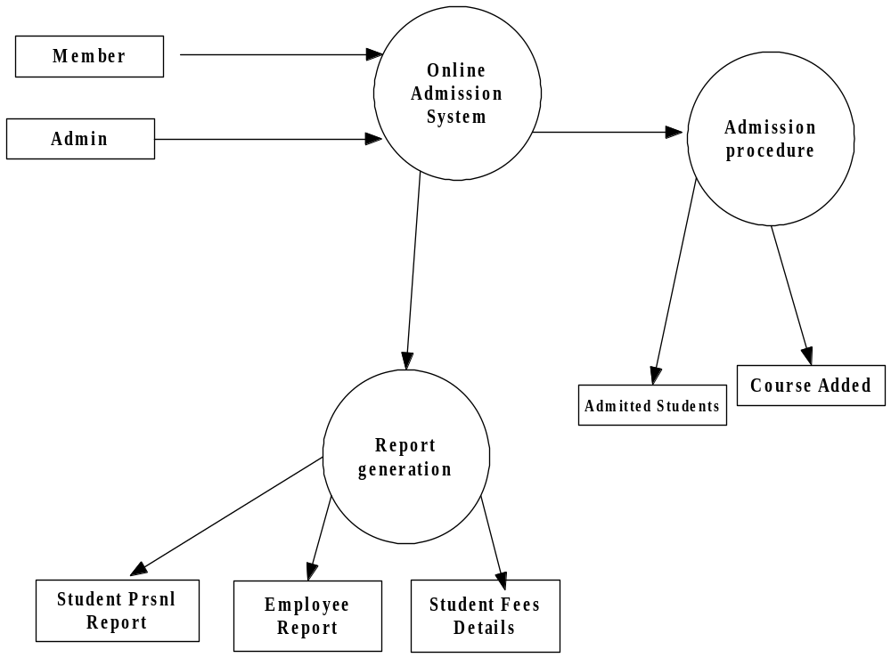

Entity Diagrams

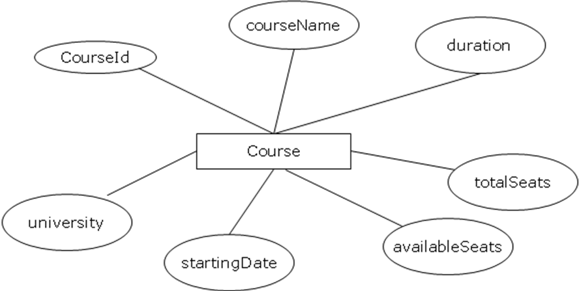

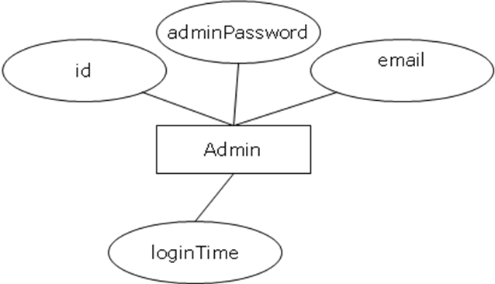

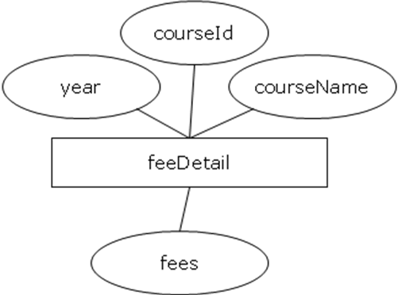

Entity Relation Diagram

Seat status

Create
Add
Apply
Allot seats
Admin
Member
Course
Fees Detail
Student

7. Database Design
Database is created in SQLSERVER-2005.
7.1. Course Details
This Relation will keep the information about the courses.

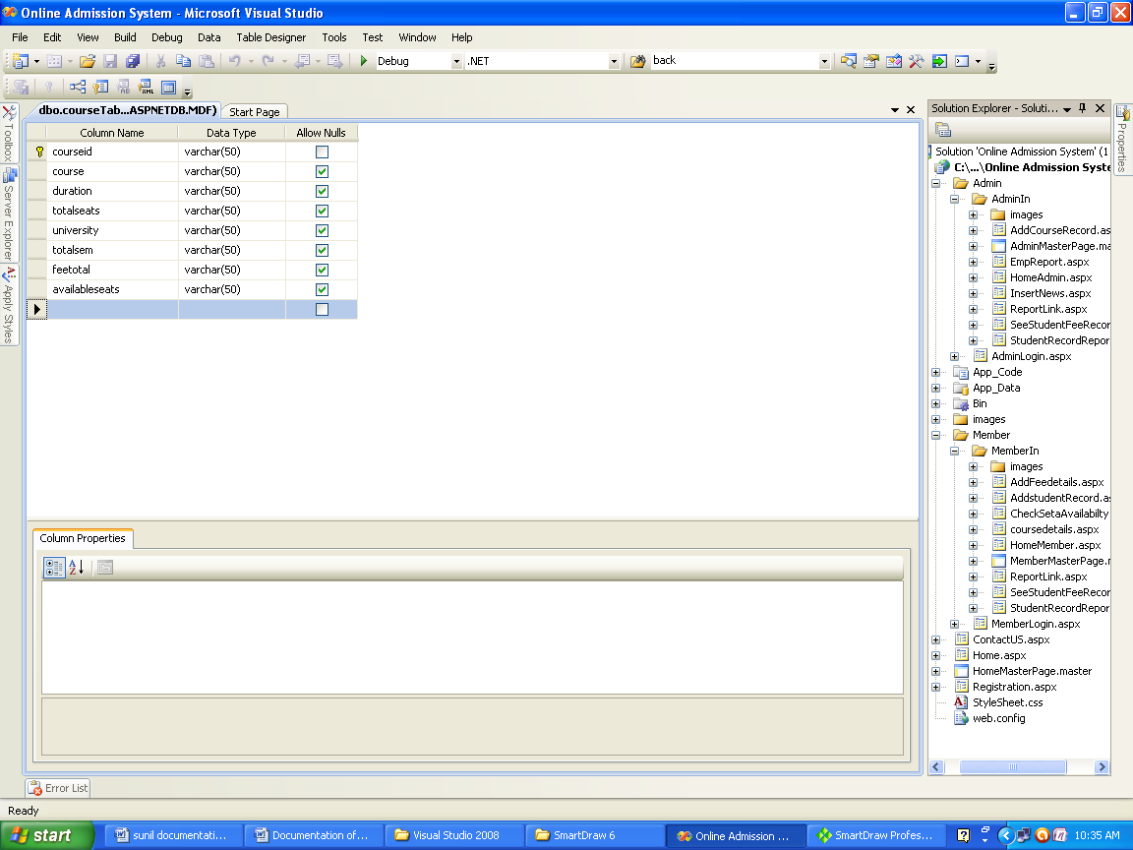

7.2. Employee Table
This relation will keep the record of employees.
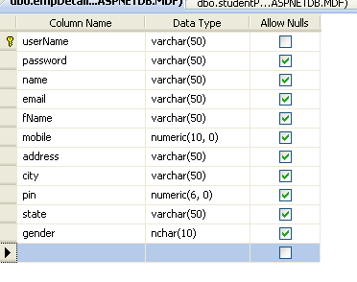

7.3.Initial rollno table
This Relation will maintain record of initial rollno generated.
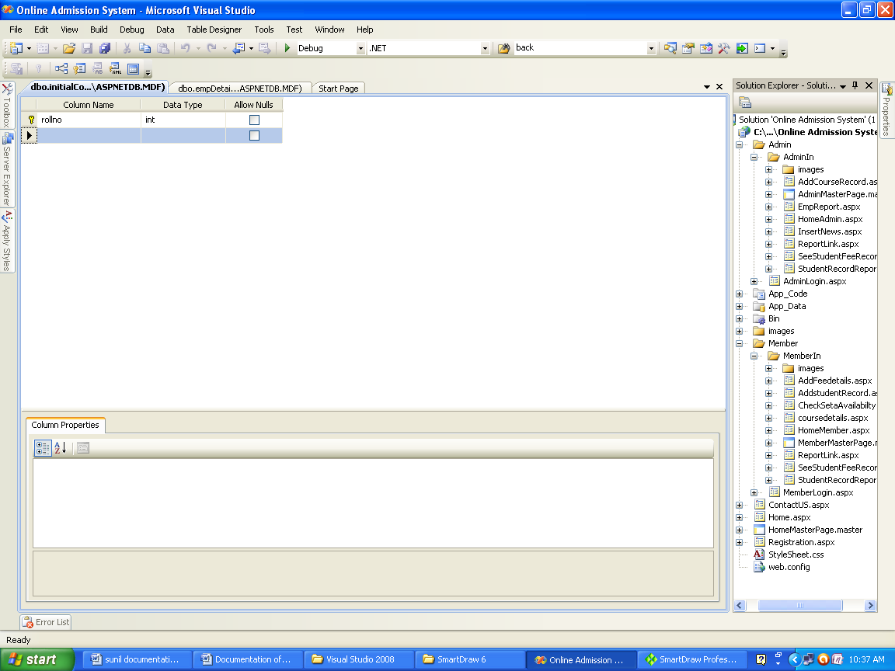

7.4 Students Detail
This Relation will maintain record of students.
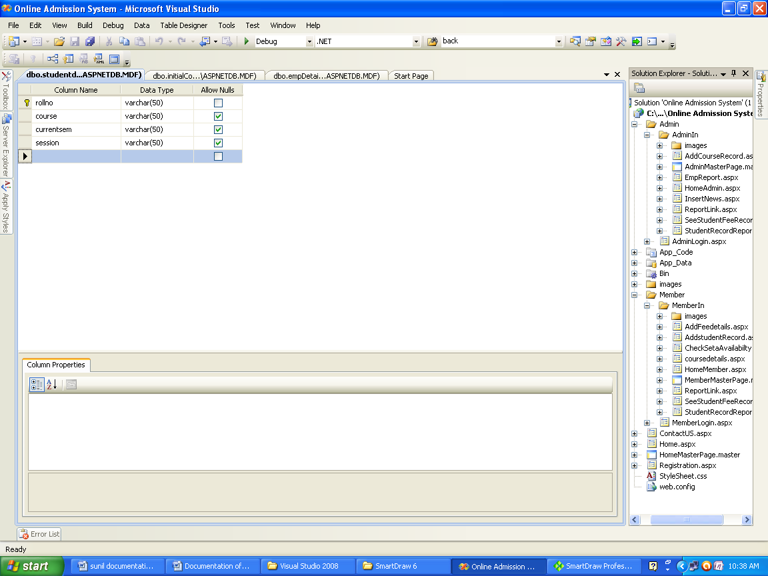

7.5News Info
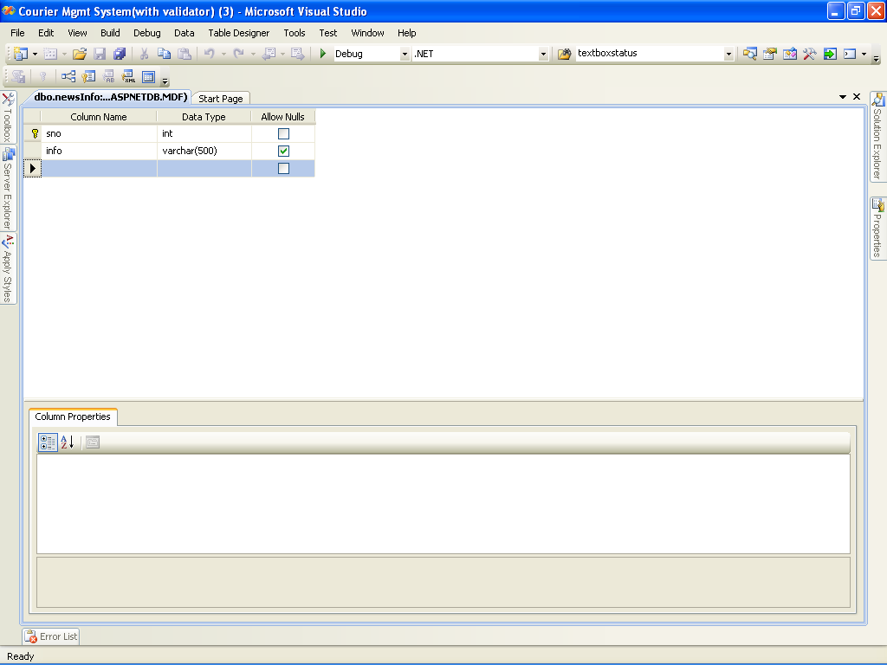

7.6Student Fees Details
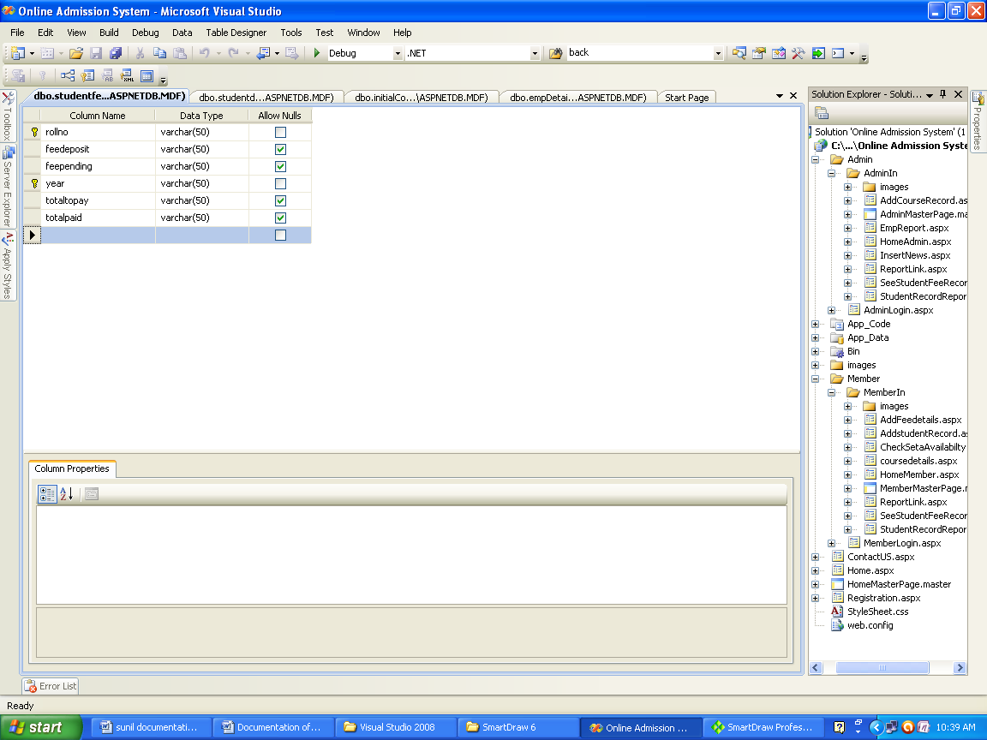

7.7Student Personal details

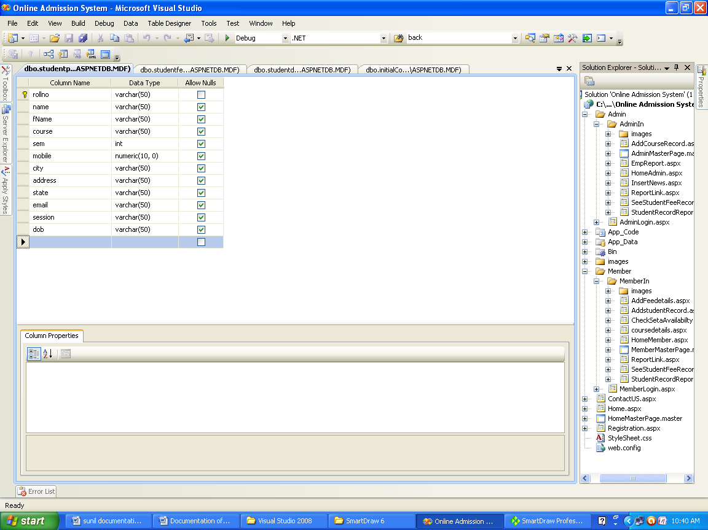

Tools/Platforms & Software

Platforms: | Windows Server 2000/2003
For Application Development: | Visual C#.NET & ASP.NET
Database Application: | SQL SERVER

Hardware Requirement
- Pentium IV Processor
- 512 MB RAM
- 40 GB HDD
- Color Monitor
- Keyboard, Mouse

8.0 Snap Shots

A user interface is a means by which a user interacts with an application. On the other hand GUI based software provides a graphical interface for interaction with an application. GUI are easy to learn and use as one do not have to remember any command or syntax. Most of the command can be executed using the mouse.
Input screen are designed using ASP.Net Web control. We have used procedure and function to increase reusability of code.
The detailed list along with the layouts are as follows-:

Home Page

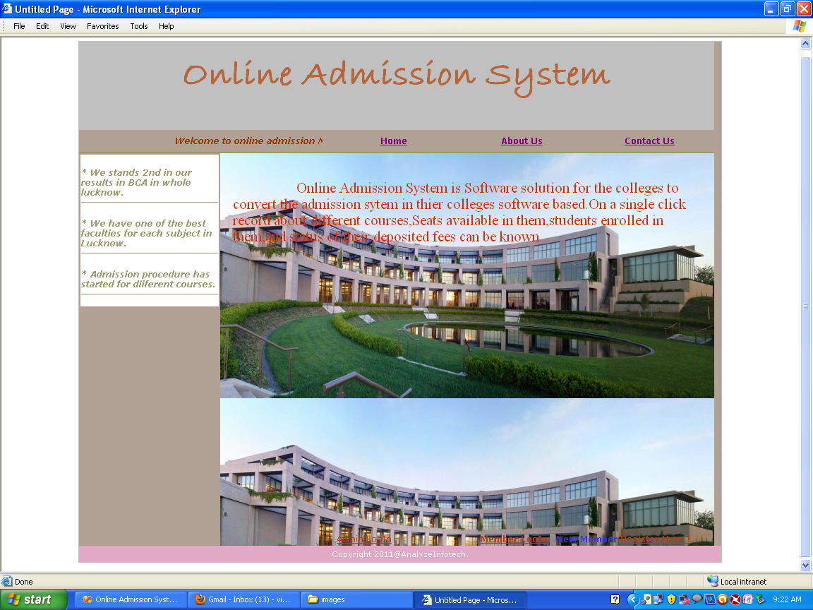

Member Panel

User Registration

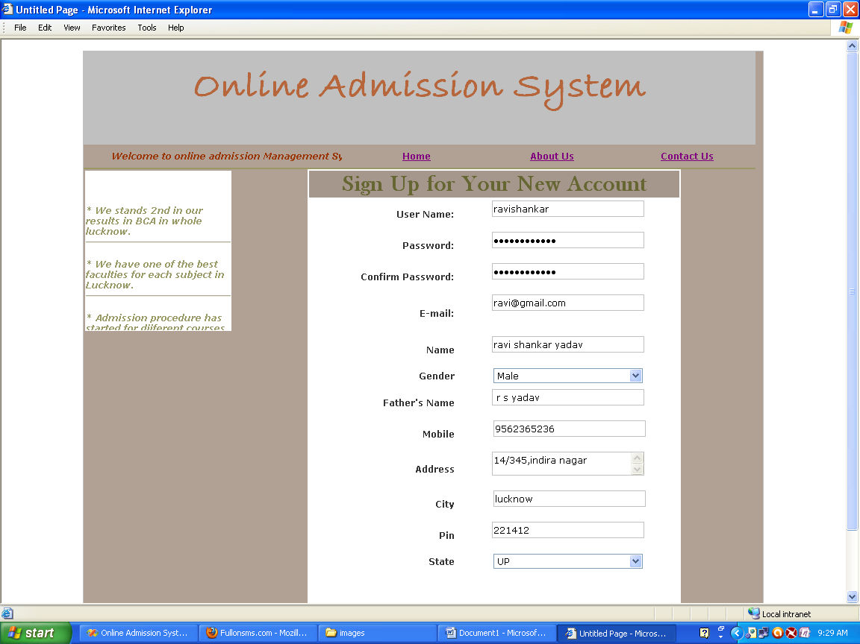

User Login

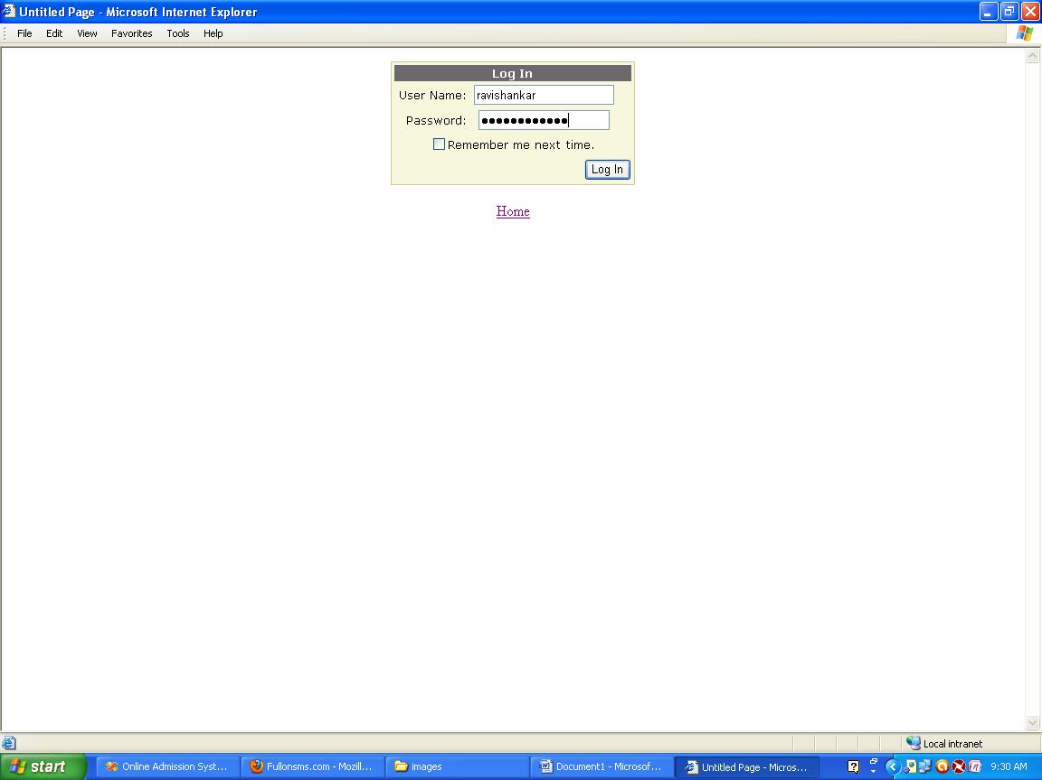

Home page of Member Panel

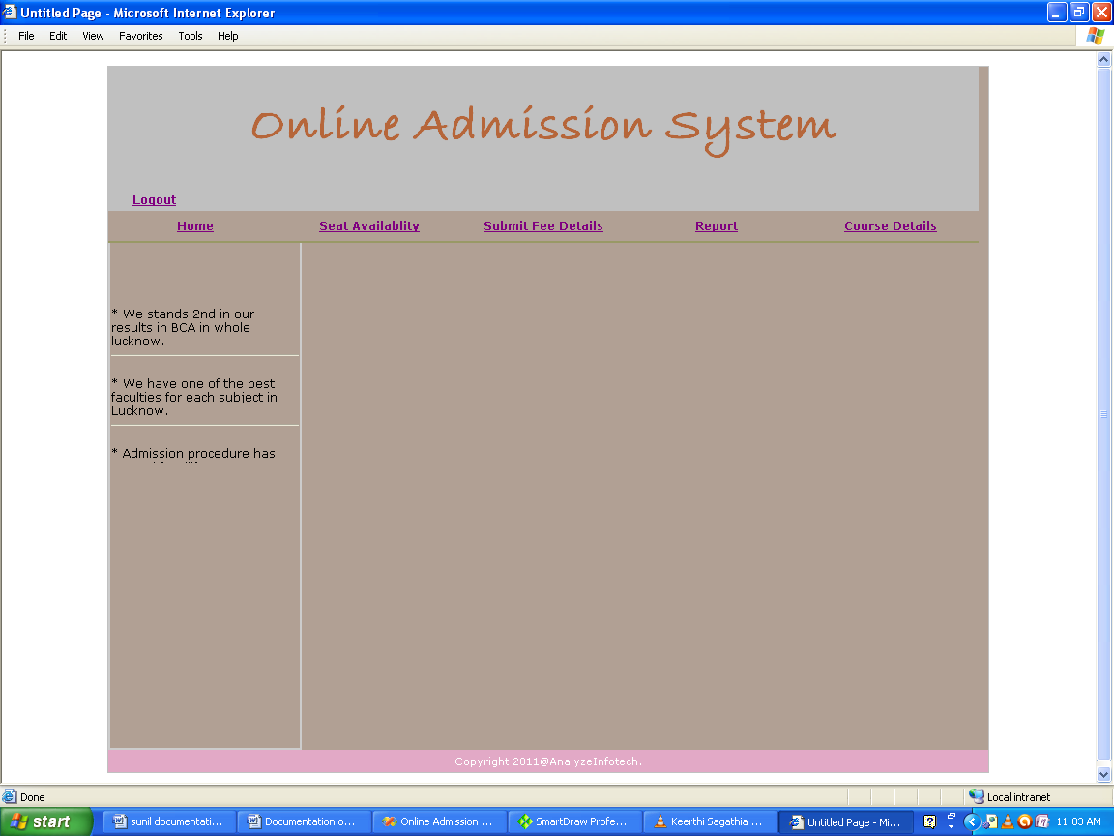

Add student Counselling

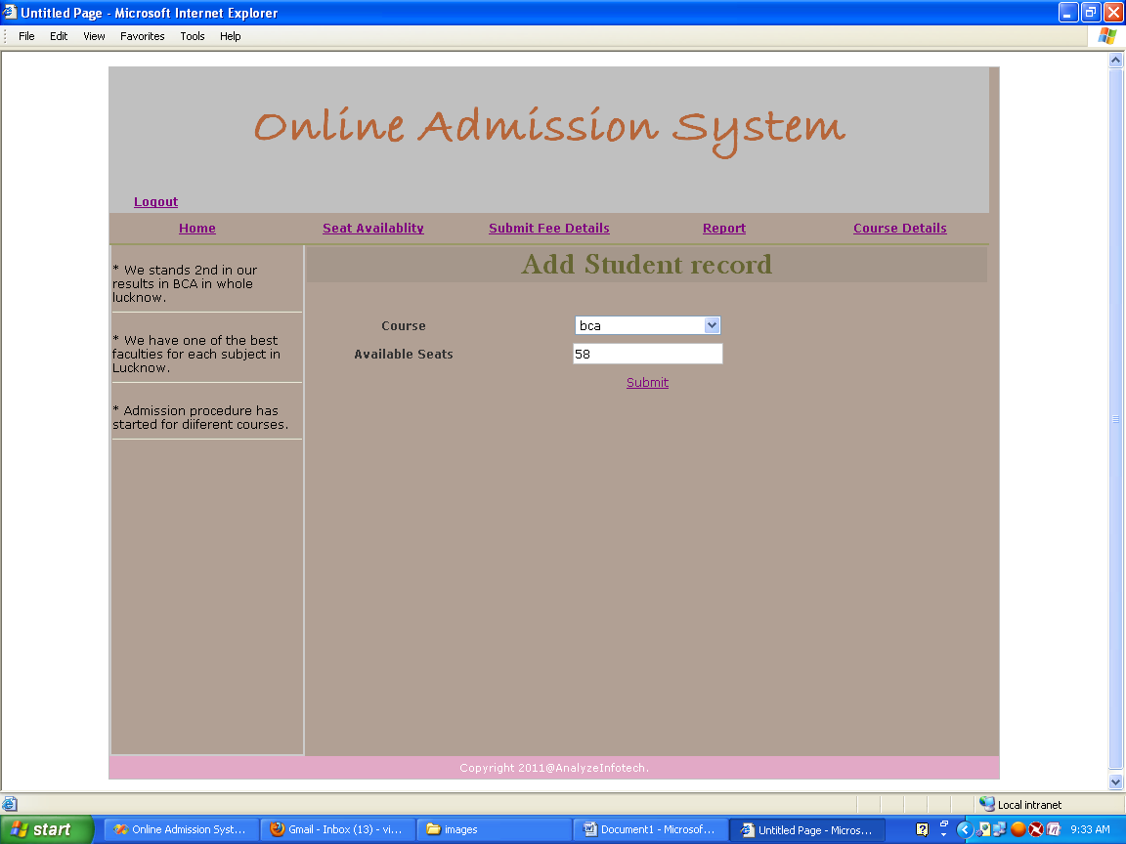

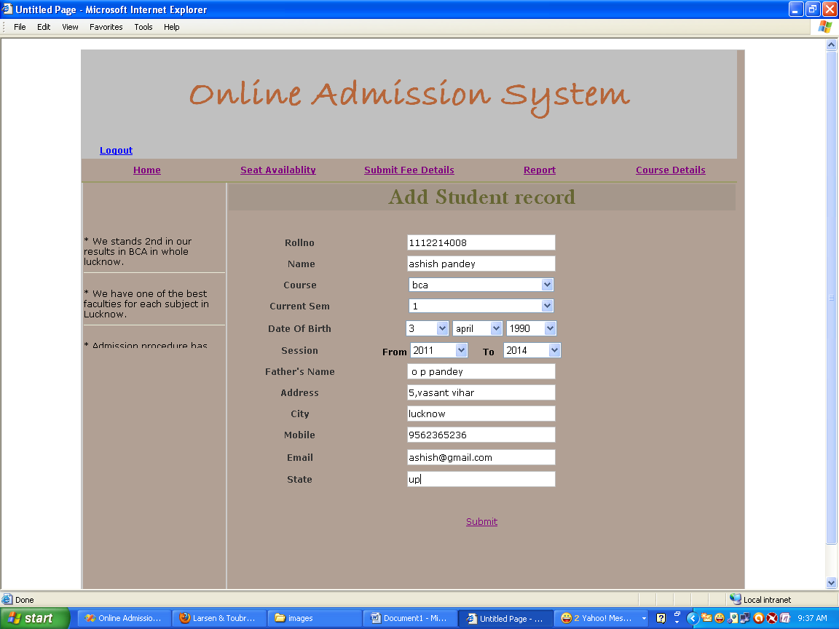

Add Fees details

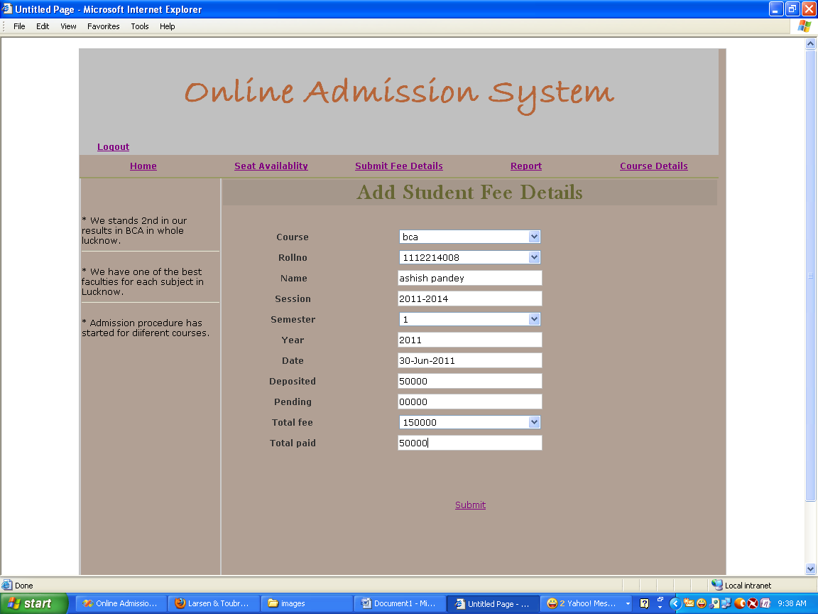

Fees details Report

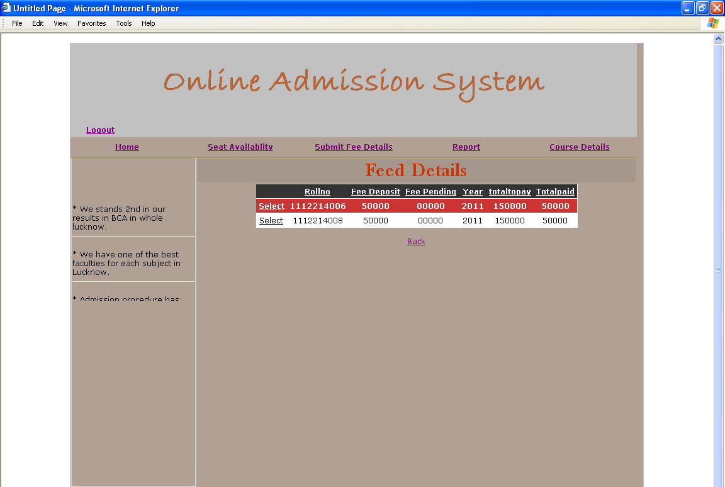

Course Details Report

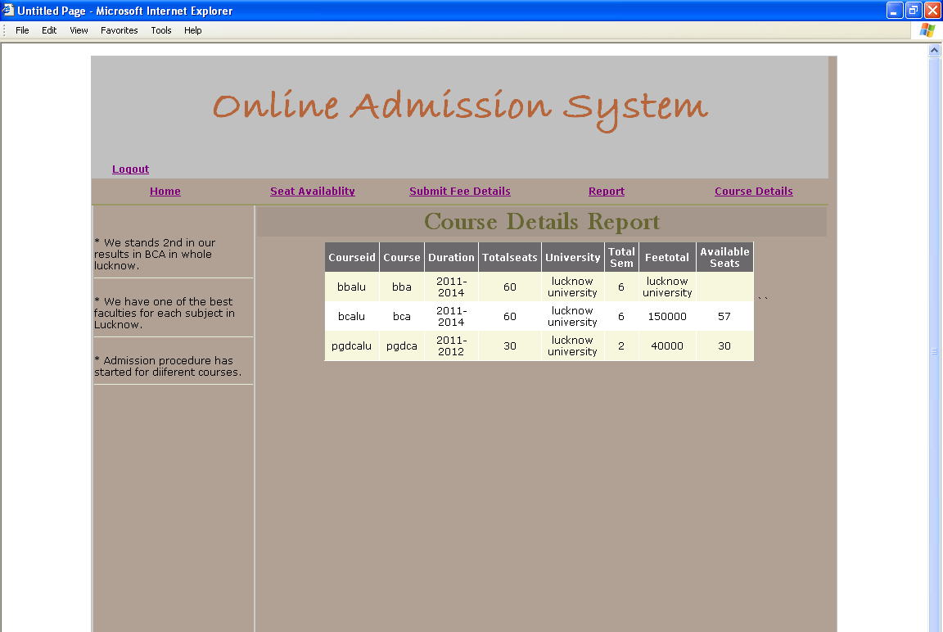

Student Details Report

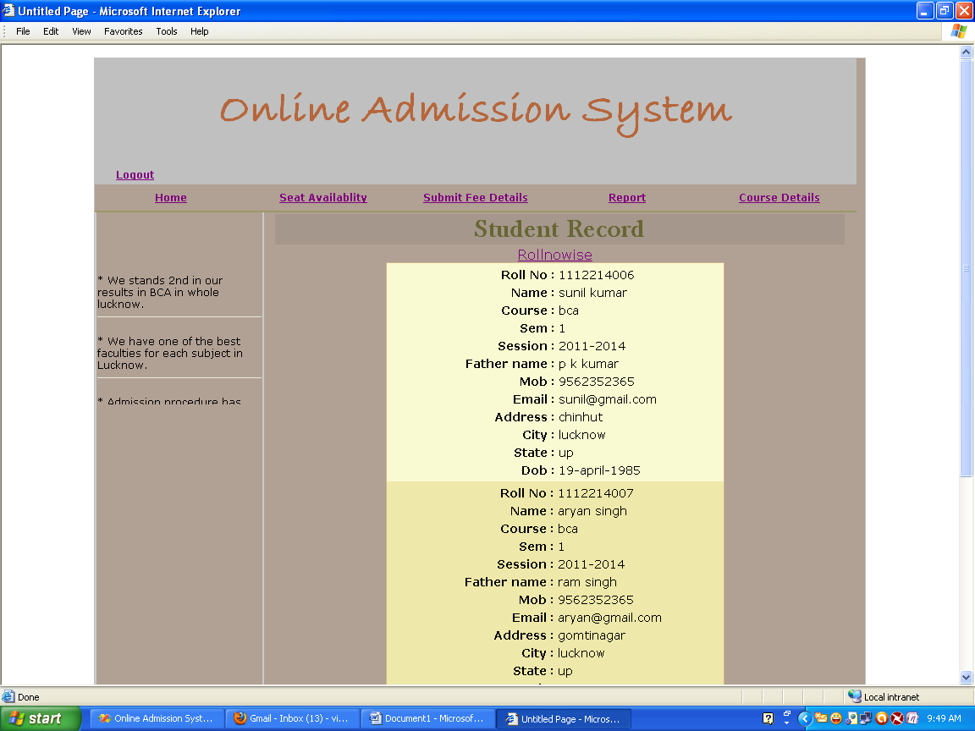

Reports

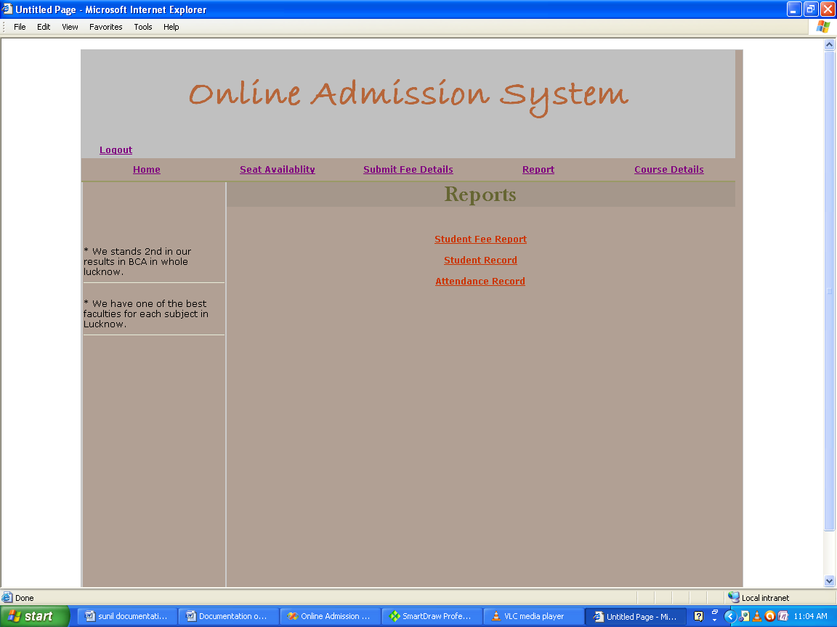

Admin Panel

Admin Login

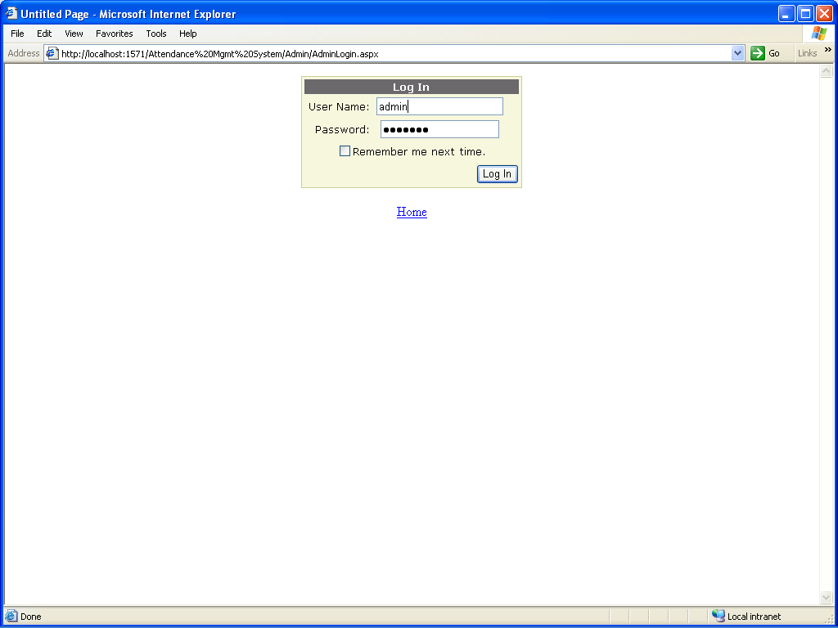

Add News

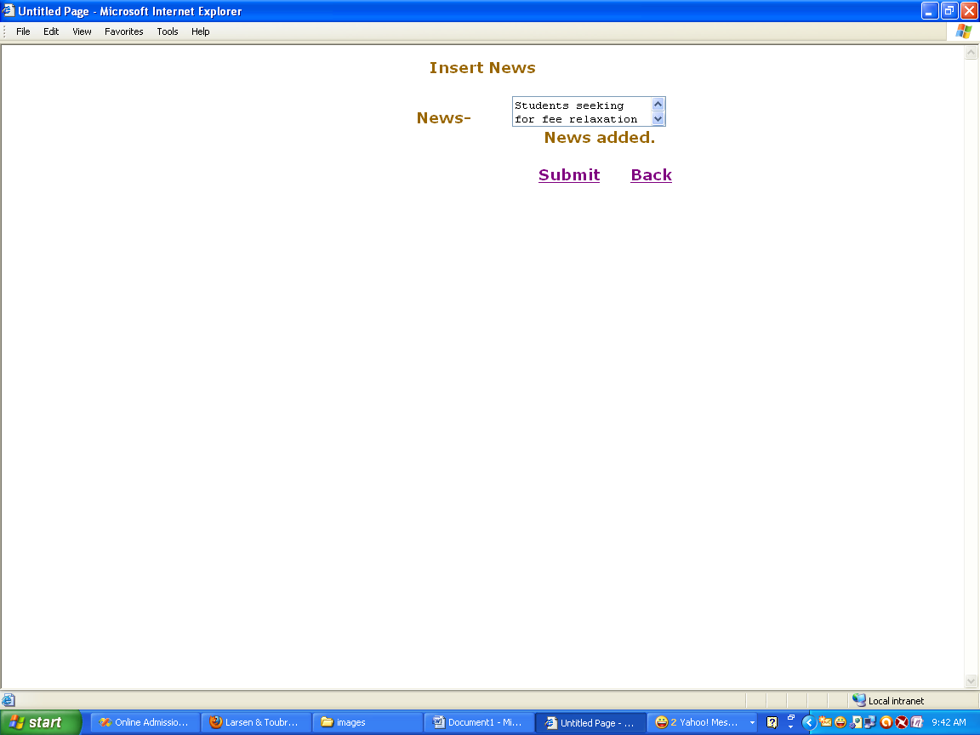

Home

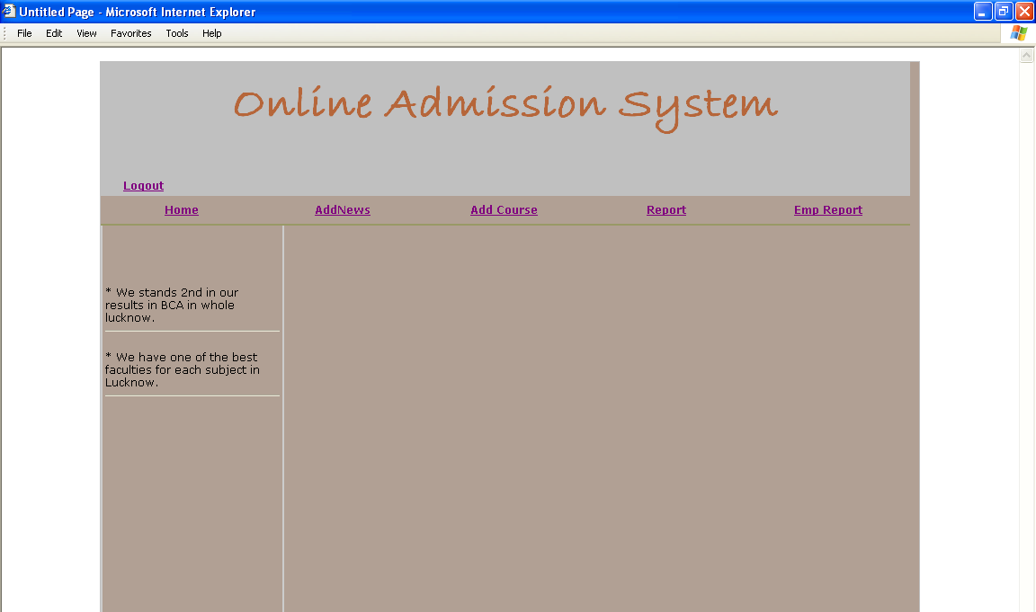

Add Course

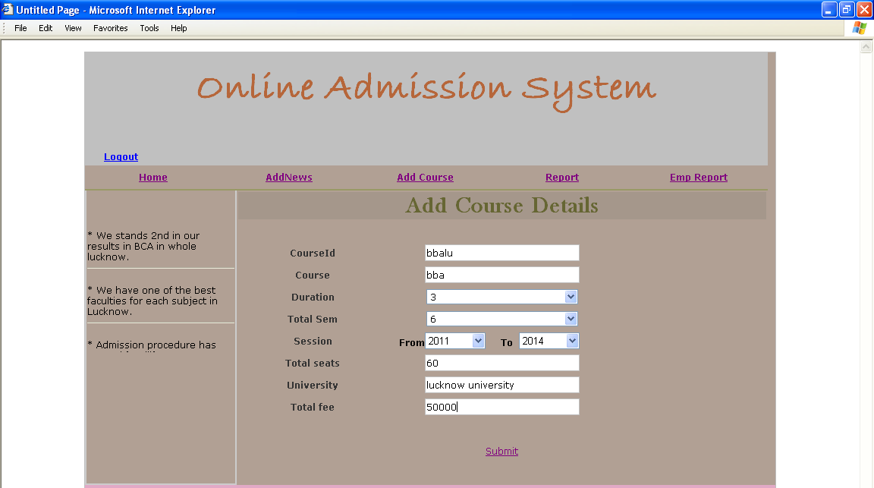

Employee Details Report

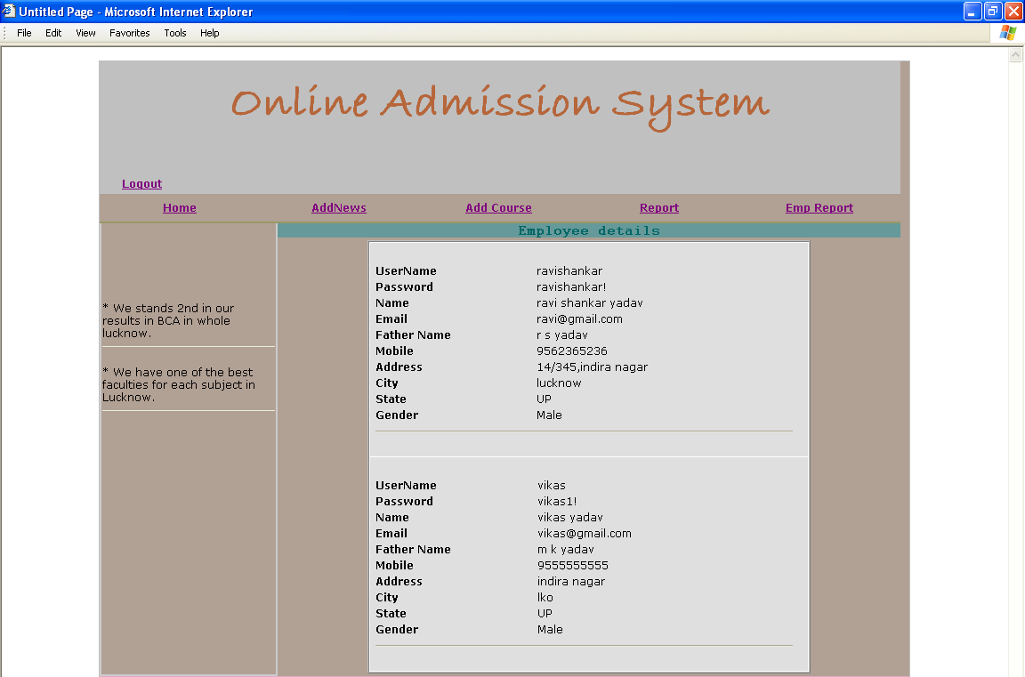

Coding
User Registration

using System;
using System.Collections;
using System.Configuration;
using System.Data;
using System.Linq;
using System.Web;
using System.Web.Security;
using System.Web.UI;
using System.Web.UI.HtmlControls;
using System.Web.UI.WebControls;
using System.Web.UI.WebControls.WebParts;
using System.Xml.Linq;
using System.Data.SqlClient;

public partial class Registration : System.Web.UI.Page
{
SqlConnection con = new SqlConnection();
SqlCommand cmd = new SqlCommand();
protected void Page_Load(object sender, EventArgs e)
{
con.ConnectionString = DbConnection.dbconnection();
cmd.Connection = con;

}
protected void CreateUserWizard1_CreatedUser(object sender, EventArgs e)
{
con.Open();
try
{

TextBox usrname = (TextBox)wizardID.ContentTemplateContainer.FindControl("UserName");
TextBox passwordlocal = (TextBox)wizardID.ContentTemplateContainer.FindControl("Password");
TextBox emaillocal = (TextBox)wizardID.ContentTemplateContainer.FindControl("Email");
TextBox namelocal = (TextBox)wizardID.ContentTemplateContainer.FindControl("TextBoxName");
DropDownList genderlocal = (DropDownList)wizardID.ContentTemplateContainer.FindControl("DropDownListGender");
TextBox fatherlocal = (TextBox)wizardID.ContentTemplateContainer.FindControl("TextBoxFatherName");

TextBox moblocal = (TextBox)wizardID.ContentTemplateContainer.FindControl("TextBoxMob");
TextBox addlocal = (TextBox)wizardID.ContentTemplateContainer.FindControl("TextBoxAdd");
TextBox citylocal = (TextBox)wizardID.ContentTemplateContainer.FindControl("TextBoxCity");
TextBox pinlocal = (TextBox)wizardID.ContentTemplateContainer.FindControl("TextBoxPin");
DropDownList statelocal = (DropDownList)wizardID.ContentTemplateContainer.FindControl("DropDownListState");

Roles.AddUserToRole(usrname.Text, "member_role");

cmd.CommandText = "INSERT INTO empDetails(userName,password,Name,email,fName,mobile,address,city,pin,state,gender) VALUES(@userName,@password,@Name,@email,@fName,@mobile,@address,@city,@pin,@state,@gender)";
cmd.Parameters.AddWithValue("@userName", usrname.Text);
cmd.Parameters.AddWithValue("@password", passwordlocal.Text);
cmd.Parameters.AddWithValue("@email", emaillocal.Text);
cmd.Parameters.AddWithValue("@Name", namelocal.Text);
cmd.Parameters.AddWithValue("@gender", genderlocal.SelectedValue);
cmd.Parameters.AddWithValue("@fName", fatherlocal.Text);

cmd.Parameters.AddWithValue("@mobile", moblocal.Text);
cmd.Parameters.AddWithValue("@address", addlocal.Text);
cmd.Parameters.AddWithValue("@city", citylocal.Text);
cmd.Parameters.AddWithValue("@state", statelocal.SelectedValue);

cmd.Parameters.AddWithValue("@pin", pinlocal.Text);

cmd.ExecuteNonQuery();
}
catch (Exception ex)
{
con.Close();
}
}
}

Member Login

using System;
using System.Collections;
using System.Configuration;
using System.Data;
using System.Linq;
using System.Web;
using System.Web.Security;
using System.Web.UI;
using System.Web.UI.HtmlControls;
using System.Web.UI.WebControls;
using System.Web.UI.WebControls.WebParts;
using System.Xml.Linq;
using System.Data.SqlClient;
public partial class Admin_Default : System.Web.UI.Page
{
protected void Page_Load(object sender, EventArgs e)
{

}
protected void LoginButton_Click(object sender, EventArgs e)
{
//----Establishing Database Connectivity------------------------
SqlConnection Con = new SqlConnection(DbConnection.dbconnection());
SqlCommand Cmd = new SqlCommand();
SqlDataReader Dr = null;

Cmd.Connection = Con;
//==============================================================
try
{

Con.Open();
Cmd.CommandText = "SELECT * FROM empDetails";
Dr = Cmd.ExecuteReader();
if(Roles.IsUserInRole(Login1.UserName,"member_role")==true)
{
while (Dr.Read())
{
string str1 = Dr["userName"].ToString();
string str2 = Dr["password"].ToString();

if (Login1.UserName == str1 && Login1.Password.ToString() == str2 )
{

Session["userNameInfo"] =Login1.UserName.ToString();
Response.Redirect("~/Member/MemberIn/HomeMember.aspx");

}
}

}
}

catch (Exception ex)
{

}
finally
{
if (Con.State == ConnectionState.Open) Con.Close();
}
}
}

Home page

using System;
using System.Collections;
using System.Configuration;
using System.Data;
using System.Linq;
using System.Web;
using System.Web.Security;
using System.Web.UI;
using System.Web.UI.HtmlControls;
using System.Web.UI.WebControls;
using System.Web.UI.WebControls.WebParts;
using System.Xml.Linq;

public partial class Member_MemberIn_Default : System.Web.UI.Page
{

protected void Page_Load(object sender, EventArgs e)
{
string str = Session["userNameInfo"].ToString();
if(Roles.IsUserInRole(str, "member_role") == true)
{
}
else
{
Response.Redirect("MemberLogin.aspx");
}

}
}

Check seat Availability

using System;
using System.Collections;
using System.Configuration;
using System.Data;
using System.Linq;
using System.Web;
using System.Web.Security;
using System.Web.UI;
using System.Web.UI.HtmlControls;
using System.Web.UI.WebControls;
using System.Web.UI.WebControls.WebParts;
using System.Xml.Linq;
using System.Data.SqlClient;

public partial class Member_MemberIn_Default : System.Web.UI.Page
{
SqlConnection Con = new SqlConnection(DbConnection.dbconnection());
SqlCommand Cmd = new SqlCommand();
SqlTransaction trans = null;
string strcode = "";
SqlDataReader dr = null;

protected void Page_Load(object sender, EventArgs e)
{

Cmd.Connection = Con;
string str = Session["userNameInfo"].ToString();
if (Roles.IsUserInRole(str, "member_role") == true)
{
}
else
{
Response.Redirect("MemberLogin.aspx");

}
Con.Open();
if (IsPostBack)
{
Cmd.CommandText = "select availableseats from courseTable where course=@course";
Cmd.Parameters.AddWithValue("@course",DropDownList1.SelectedValue);
dr = Cmd.ExecuteReader();
if (dr.Read())
{

TextBox1.Text = dr["availableseats"].ToString();

}

dr.Close();
Cmd.Parameters.Clear();
}

Con.Close();
}
protected void LinkButton1_Click(object sender, EventArgs e)
{
int a= int.Parse(TextBox1.Text.ToString());
if (a != 0)
{
Response.Redirect("~/Member/MemberIn/AddstudentRecord.aspx");

}
}
}

Add Student Counselling

using System;
using System.Collections;
using System.Configuration;
using System.Data;
using System.Linq;
using System.Web;
using System.Web.Security;
using System.Web.UI;
using System.Web.UI.HtmlControls;
using System.Web.UI.WebControls;
using System.Web.UI.WebControls.WebParts;
using System.Xml.Linq;
using System.Data.SqlClient;

public partial class Member_MemberIn_Default : System.Web.UI.Page
{
SqlConnection Con = new SqlConnection(DbConnection.dbconnection());
SqlCommand Cmd = new SqlCommand();
SqlTransaction trans = null;
string strcode = "";
SqlDataReader dr = null;

protected void Page_Load(object sender, EventArgs e)
{
DropDownList2.Items.Insert(0,"Select");
DropDownList3.Items.Insert(0, "Select");
DropDownList4.Items.Insert(0, "Select");
DropDownList5.Items.Insert(0, "Select");
Cmd.Connection = Con;

string str = Session["userNameInfo"].ToString();
if (Roles.IsUserInRole(str, "member_role") == true)
{
}
else
{
Response.Redirect("MemberLogin.aspx");
}
Con.Open();
Cmd.CommandText = "select rollno from initialCodeTable";
dr = Cmd.ExecuteReader();
if (dr.Read())
{

strcode = dr[0].ToString();

}
TextBoxRollno.Text = strcode;
dr.Close();
Cmd.Parameters.Clear();
Con.Close();
}
protected void LinkButton1_Click(object sender, EventArgs e)
{
Con.Open();
trans =Con.BeginTransaction();
Cmd.Transaction = trans;
try
{
Label1.Text = "";
Cmd.CommandText = "INSERT INTO studentdetails(rollno,course,currentsem,session) VALUES(@rollno,@course,@currentsem,@session)";
Cmd.Parameters.AddWithValue("@rollno", strcode);
Cmd.Parameters.AddWithValue("@course", DropDownList1.SelectedValue);
Cmd.Parameters.AddWithValue("@currentsem",

DropDownList2.SelectedValue);
Cmd.Parameters.AddWithValue("@session", DropDownList6.SelectedValue + "-" + DropDownList7.SelectedValue);
Cmd.ExecuteNonQuery();
Cmd.Parameters.Clear();
Cmd.CommandText = "INSERT INTO studentprsnlinfo(rollno,name,fname,course,sem,mobile,city,address,state,email,session,dob) VALUES(@rollno,@name,@fname,@course,@sem,@mobile,@city,@address,@state,@email,@session,@dob)";
Cmd.Parameters.AddWithValue("@rollno", strcode);
Cmd.Parameters.AddWithValue("@name", TextBoxName.Text);
Cmd.Parameters.AddWithValue("@course", DropDownList1.SelectedValue);
Cmd.Parameters.AddWithValue("@sem", DropDownList2.SelectedValue);
Cmd.Parameters.AddWithValue("@dob", DropDownList3.SelectedValue + "-" + DropDownList4.SelectedValue + "-" + DropDownList5.SelectedValue);
Cmd.Parameters.AddWithValue("@session", DropDownList6.SelectedValue + "-" + DropDownList7.SelectedValue);
Cmd.Parameters.AddWithValue("@fName", TextBox1.Text);
Cmd.Parameters.AddWithValue("@address", TextBox2.Text);
Cmd.Parameters.AddWithValue("@city", TextBox3.Text);
Cmd.Parameters.AddWithValue("@mobile", TextBox4.Text);
Cmd.Parameters.AddWithValue("@email", TextBox5.Text);
Cmd.Parameters.AddWithValue("@state", TextBox6.Text);
Cmd.ExecuteNonQuery();
Cmd.CommandText = "UPDATE initialCodeTable SET rollno=rollno+1";
Cmd.ExecuteNonQuery();
Cmd.Parameters.Clear();

Cmd.CommandText = "UPDATE courseTable SET availableseats=availableseats-1 where course=@course";
Cmd.Parameters.AddWithValue("@course",DropDownList1.SelectedValue);
Cmd.ExecuteNonQuery();

Label1.Text = "New student record was successfully inserted.";
trans.Commit();
TextBox1.Text = "";
TextBox2.Text = "";
TextBox3.Text = "";
TextBox4.Text = "";
TextBox5.Text = "";
TextBox6.Text = "";
TextBoxRollno.Text = "";
TextBoxRollno.Text = "";

}
catch (Exception ex)
{
Label1.Text = "New student record was not successfully inserted.";
trans.Rollback();
}
}
}

Add Fee Details
using System;
using System.Collections;
using System.Configuration;
using System.Data;
using System.Linq;
using System.Web;
using System.Web.Security;
using System.Web.UI;
using System.Web.UI.HtmlControls;
using System.Web.UI.WebControls;
using System.Web.UI.WebControls.WebParts;
using System.Xml.Linq;
using System.Data.SqlClient;

public partial class Member_MemberIn_Default : System.Web.UI.Page
{
SqlConnection Con = new SqlConnection(DbConnection.dbconnection());
SqlCommand Cmd = new SqlCommand();
SqlDataReader Dr = null;
protected void Page_Load(object sender, EventArgs e)
{
string str = Session["userNameInfo"].ToString();
if (Roles.IsUserInRole(str, "member_role") == true)
{
}
else
{
Response.Redirect("MemberLogin.aspx");
}

DropDownList2.Items.Insert(0, "Select");
Cmd.Connection = Con;
Con.Open();

Cmd.CommandText = "SELECT * FROM studentprsnlinfo WHERE rollno='" + DropDownList2.SelectedValue.ToString() + "'";
Dr = Cmd.ExecuteReader();
if (IsPostBack)
{
Label1.Text = "";

if (Dr.Read())
{
if (DropDownList2.SelectedValue != "Select")
{
TextBoxName.Text = Dr["name"].ToString();
TextBox1.Text = Dr["session"].ToString();
TextBoxYear.Text = System.DateTime.Now.ToString("yyyy");
TextBoxDate.Text = System.DateTime.Now.ToString("dd-MMM-yyyy");

}
}
Dr.Close();
/*Cmd.CommandText = "SELECT * FROM courseTable WHERE course=@course";
Cmd.Parameters.AddWithValue("@course", DropDownList1.SelectedValue);
Dr = Cmd.ExecuteReader();
if (Dr.Read())
TextBoxtotal.Text = Dr["feetotal"].ToString();
Dr.Close();*/

}
Con.Close();
}
protected void LinkButton1_Click(object sender, EventArgs e)
{

Con.Open();
try
{

Cmd.CommandText = "SELECT * FROM studentfeedetails WHERE rollno=@rollno AND year=@year";
Cmd.Parameters.AddWithValue("@rollno", DropDownList2.SelectedValue);
Cmd.Parameters.AddWithValue("@year", TextBoxYear.Text);
Dr = Cmd.ExecuteReader();
if (Dr.Read())
{
Dr.Close();
Cmd.Parameters.Clear();
Cmd.CommandText = "UPDATE studentfeedetails SET feedeposit=@feedeposit,feepending=@feepending,totalpaid=@totalpaid,year=@year";
Cmd.Parameters.AddWithValue("@year", TextBoxYear.Text);
Cmd.Parameters.AddWithValue("@feedeposit", TextBox2.Text);
Cmd.Parameters.AddWithValue("@feepending", TextBoxpending.Text);
Cmd.Parameters.AddWithValue("@totalpaid",TextBoxtotalpaid.Text);
Cmd.ExecuteNonQuery();
Cmd.Parameters.Clear();
Label1.Text = "Fee Details added.";

}
else
{
Dr.Close();
Cmd.Parameters.Clear();
Cmd.CommandText = "INSERT INTO studentfeedetails(rollno,feedeposit,feepending,totalpaid,year,totaltopay)VALUES(@rollno,@feedeposit,@feepending,@totalpaid,@year,@totaltopay)";

Cmd.Parameters.AddWithValue("@rollno", DropDownList2.SelectedValue);
Cmd.Parameters.AddWithValue("@year", TextBoxYear.Text);
Cmd.Parameters.AddWithValue("@feedeposit", TextBox2.Text);
Cmd.Parameters.AddWithValue("@feepending", TextBoxpending.Text);
Cmd.Parameters.AddWithValue("@totalpaid",TextBoxtotalpaid.Text);
Cmd.Parameters.AddWithValue("@totaltopay",DropDownList4.SelectedValue);
Cmd.ExecuteNonQuery();
Cmd.Parameters.Clear();
Label1.Text = "Fee Details added.";
}

}
catch (Exception ex)
{
Label1.Text = "Fee Details could not be added.";
}

}

}

Home Page

using System;
using System.Collections;
using System.Configuration;
using System.Data;
using System.Linq;
using System.Web;
using System.Web.Security;
using System.Web.UI;
using System.Web.UI.HtmlControls;
using System.Web.UI.WebControls;
using System.Web.UI.WebControls.WebParts;
using System.Xml.Linq;

public partial class Member_MemberIn_Default : System.Web.UI.Page
{

protected void Page_Load(object sender, EventArgs e)
{
string str = Session["userNameInfo"].ToString();
if(Roles.IsUserInRole(str, "member_role") == true)
{
}
else
{
Response.Redirect("MemberLogin.aspx");
}

}
}

Admin Login
using System;
using System.Collections;
using System.Configuration;
using System.Data;
using System.Linq;
using System.Web;
using System.Web.Security;
using System.Web.UI;
using System.Web.UI.HtmlControls;
using System.Web.UI.WebControls;
using System.Web.UI.WebControls.WebParts;
using System.Xml.Linq;
using System.Data.SqlClient;

public partial class Admin_Default : System.Web.UI.Page
{
protected void Page_Load(object sender, EventArgs e)
{

}
protected void LoginButton_Click(object sender, EventArgs e)
{
//----Establishing Database Connectivity------------------------
SqlConnection Con = new SqlConnection(DbConnection.dbconnection());
SqlCommand Cmd = new SqlCommand();
Cmd.Connection = Con;
//==============================================================
try
{
Con.Open();
if (Roles.IsUserInRole(Login1.UserName, "admin_role") == true)

{
Session["adminUserName"] = Login1.UserName.ToString();
Response.Redirect("AdminIn/HomeAdmin.aspx");
}

catch (Exception ex)
{

}
finally
{
if (Con.State == ConnectionState.Open) Con.Close();
}
}
}

Add Course

using System;
using System.Collections;
using System.Configuration;
using System.Data;
using System.Linq;
using System.Web;
using System.Web.Security;
using System.Web.UI;
using System.Web.UI.HtmlControls;
using System.Web.UI.WebControls;
using System.Web.UI.WebControls.WebParts;
using System.Xml.Linq;
using System.Data.SqlClient;

public partial class Member_MemberIn_Default : System.Web.UI.Page
{
SqlConnection Con = new SqlConnection(DbConnection.dbconnection());
SqlCommand Cmd = new SqlCommand();
SqlTransaction trans = null;
string strcode = "";
SqlDataReader dr = null;

protected void Page_Load(object sender, EventArgs e)
{
DropDownList1.Items.Insert(0,"Select");
DropDownList2.Items.Insert(0, "Select");
DropDownList6.Items.Insert(0, "Select");
DropDownList7.Items.Insert(0, "Select");
Cmd.Connection = Con;
string str = Session["userNameInfo"].ToString();
if (Roles.IsUserInRole(str, "member_role") == true)
{
}
else
{
Response.Redirect("MemberLogin.aspx");
}

}
protected void LinkButton1_Click(object sender, EventArgs e)
{
Con.Open();
trans =Con.BeginTransaction();
Cmd.Transaction = trans;
try
{
Label1.Text = "";
Cmd.CommandText = "INSERT INTO courseTable(courseid,course,duration,totalseats,university,totalsem,feetotal) VALUES(@courseid,@course,@duration,@totalseats,@university,@totalsem,@feetotal)";
Cmd.Parameters.AddWithValue("@courseid",TextBoxCourseid.Text);
Cmd.Parameters.AddWithValue("course", TextBoxcourse.Text);

Cmd.Parameters.AddWithValue("@duration", DropDownList6.SelectedValue + "-" + DropDownList7.SelectedValue);
Cmd.Parameters.AddWithValue("@totalseats",TextBox1.Text);
Cmd.Parameters.AddWithValue("@university", TextBox2.Text);
Cmd.Parameters.AddWithValue("@totalsem",DropDownList2.SelectedValue );
Cmd.Parameters.AddWithValue("@feetotal", TextBox2.Text);

Cmd.ExecuteNonQuery();
Label1.Text = "New course record was successfully inserted.";
trans.Commit();
TextBox1.Text = "";
TextBox2.Text = "";
TextBox2.Text = "";
TextBoxCourseid.Text = "";
TextBoxcourse.Text = "";

}
catch (Exception ex)
{
Label1.Text = "New course record was not successfully inserted.";

trans.Rollback();
}
}
}

Insert news
using System;
using System.Collections;
using System.Configuration;
using System.Data;
using System.Linq;
using System.Web;
using System.Web.Security;
using System.Web.UI;
using System.Web.UI.HtmlControls;
using System.Web.UI.WebControls;
using System.Web.UI.WebControls.WebParts;
using System.Xml.Linq;
using System.Data.SqlClient;

public partial class InsertNews : System.Web.UI.Page
{
SqlConnection con = new SqlConnection();
SqlCommand cmd = new SqlCommand();
protected void Page_Load(object sender, EventArgs e)
{
con.ConnectionString = @"Data Source=.\SQLEXPRESS;AttachDbFilename=|DataDirectory|\ASPNETDB.MDF;Integrated Security=True;User Instance=True";
cmd.Connection = con;
}
protected void LinkButton1_Click(object sender, EventArgs e)
{

con.Open();
try
{
cmd.CommandText = "INSERT INTO newsInfo(info) VALUES(@info)";
cmd.Parameters.AddWithValue("@info", TextBox1.Text);
cmd.ExecuteNonQuery();
Label1.Text = "News added.";
}

catch (Exception ex)
{
Label1.Text = "News could not be added successfully.";
}
}
}

Display News

using System;
using System.Collections;
using System.Configuration;
using System.Data;
using System.Linq;
using System.Web;
using System.Web.Security;
using System.Web.UI;
using System.Web.UI.WebControls;
using System.Web.UI.WebControls.WebParts;
using System.Web.UI.HtmlControls;
using System.Xml.Linq;
using System.Data.SqlClient;
public partial class AdminPanel_admin_MasterPage : System.Web.UI.MasterPage
{
SqlConnection con = new SqlConnection();
protected void Page_Load(object sender, EventArgs e)
{
string str = "";
con.ConnectionString = @"Data Source=.\SQLEXPRESS;AttachDbFilename=|DataDirectory|\ASPNETDB.MDF;Integrated Security=True;User Instance=True";
con.Open();
string str1 = "select * from newsInfo";
SqlDataAdapter da = new SqlDataAdapter(str1, con);
DataSet ds = new DataSet();
da.Fill(ds, "newsInfo");
int i = 1;

foreach (DataRow dr in ds.Tables["newsInfo"].Rows)
{

str += "* " + dr[1] + "</br><hr/></br>";
i++;
}
Label1.Text = str.ToString();
}

}

AddCourseRecord
<%@ Page Language="C#" MasterPageFile="~/Admin/AdminIn/AdminMasterPage.master" AutoEventWireup="true" CodeFile="AddCourseRecord.aspx.cs" Inherits="Member_MemberIn_Default" Title="Untitled Page" %>

<asp:Content ID="Content1" ContentPlaceHolderID="head" Runat="Server">
</asp:Content>
<asp:Content ID="Content2" ContentPlaceHolderID="ContentPlaceHolder1" Runat="Server">
<div class="ChildContainer">
<table>
<tr class="Heading3">
<td colspan="3"

style="font-family: 'Baskerville Old Face'; font-size: 30px; font-weight: bold; text-align: center; color: #666633; background-color: #A5978B;">
Add Course Details<br />
</td>
</tr>

<tr>
<td class="Column1">
&nbsp;</td>
<td class="Column2">
&nbsp;</td>
<td class="Column3">
&nbsp;</td>
</tr>

<tr>
<td class="Column1">
CourseId</td>
<td class="Column2">
<asp:TextBox ID="TextBoxCourseid" runat="server" CssClass="TextBoxMedium"></asp:TextBox>
</td>
<td class="Column3">
<asp:RequiredFieldValidator ID="RequiredFieldValidator4" runat="server"
ControlToValidate="TextBoxCourseid" ErrorMessage="Enter CourseId."></asp:RequiredFieldValidator>
</td>
</tr>

<tr>
<td class="Column1">
Course</td>
<td class="Column2">
<asp:TextBox ID="TextBoxcourse" runat="server" CssClass="TextBoxMedium"></asp:TextBox>
</td>
<td class="Column3">
<asp:RequiredFieldValidator ID="RequiredFieldValidator1" runat="server"
ControlToValidate="TextBoxcourse" ErrorMessage="Enter Course."></asp:RequiredFieldValidator>
</td>
</tr>

<tr>
<td class="Column1">
Duration</td>
<td class="Column2">
<asp:DropDownList ID="DropDownList1" runat="server" CssClass="TextBoxMedium">
<asp:ListItem>1</asp:ListItem>
<asp:ListItem>2</asp:ListItem>
<asp:ListItem>3</asp:ListItem>
<asp:ListItem>4</asp:ListItem>
</asp:DropDownList>
</td>
<td class="Column3">
<asp:RequiredFieldValidator ID="RequiredFieldValidator5" runat="server"
ControlToValidate="DropDownList1" ErrorMessage="Enter Duration."></asp:RequiredFieldValidator>
</td>
</tr>

<tr>
<td class="Column1">
Total
Sem</td>
<td class="Column2">
<asp:DropDownList ID="DropDownList2" runat="server" CssClass="TextBoxMedium">
<asp:ListItem>1</asp:ListItem>
<asp:ListItem>2</asp:ListItem>
<asp:ListItem>3</asp:ListItem>
<asp:ListItem>4</asp:ListItem>
<asp:ListItem>5</asp:ListItem>
<asp:ListItem>6</asp:ListItem>
</asp:DropDownList>

</td>
<td class="Column3">
<asp:RequiredFieldValidator ID="RequiredFieldValidator6" runat="server"
ControlToValidate="DropDownList2" ErrorMessage="Enter Totalsem."></asp:RequiredFieldValidator>
</td>
</tr>

<tr>
<td class="Column1">
Session</td>
<td class="Column2"
style="font-family: verdana; font-size: 12px; font-weight: bold; text-align: left; line-height: normal;">
&nbsp;&nbsp; From<asp:DropDownList ID="DropDownList6" runat="server" Width="80px">
<asp:ListItem>2011</asp:ListItem>
</asp:DropDownList>
&nbsp;&nbsp;&nbsp;&nbsp;To&nbsp;
<asp:DropDownList ID="DropDownList7" runat="server" Width="80px">
<asp:ListItem>2012</asp:ListItem>
<asp:ListItem>2013</asp:ListItem>
<asp:ListItem>2014</asp:ListItem>
<asp:ListItem>2015</asp:ListItem>
</asp:DropDownList>
</td>
<td class="Column3">
<asp:RequiredFieldValidator ID="RequiredFieldValidator7" runat="server"
ControlToValidate="DropDownList6" ErrorMessage="Enter Session."></asp:RequiredFieldValidator>
</td>
</tr>

<tr>
<td class="Column1">
Total seats</td>
<td class="Column2">
<asp:TextBox ID="TextBox1" runat="server" CssClass="TextBoxMedium"></asp:TextBox>
</td>
<td class="Column3">
<asp:RequiredFieldValidator ID="RequiredFieldValidator2" runat="server"
ControlToValidate="TextBox1" ErrorMessage="Enter Total seats."></asp:RequiredFieldValidator>
</td>
</tr>

<tr>
<td class="Column1">
University</td>
<td class="Column2">
<asp:TextBox ID="TextBox2" runat="server" CssClass="TextBoxMedium"></asp:TextBox>
</td>
<td class="Column3">
<asp:RequiredFieldValidator ID="RequiredFieldValidator3" runat="server"
ControlToValidate="TextBox2" ErrorMessage="Enter University."></asp:RequiredFieldValidator>
</td>
</tr>

<tr>
<td class="Column1">
Total fee</td>
<td class="Column2">
<asp:TextBox ID="TextBox3" runat="server" CssClass="TextBoxMedium"></asp:TextBox>
</td>
<td class="Column3">
<asp:RequiredFieldValidator ID="RequiredFieldValidator8" runat="server"
ControlToValidate="TextBox3" ErrorMessage="Enter Fees."></asp:RequiredFieldValidator>
</td>
</tr>

<tr>
<td class="Column1">
&nbsp;</td>
<td class="Column2">
&nbsp;</td>
<td class="Column3">
&nbsp;</td>
</tr>

<tr>
<td class="Column1">
&nbsp;</td>
<td class="Column2">
<asp:LinkButton ID="LinkButton1" runat="server" onclick="LinkButton1_Click">Submit</asp:LinkButton>
</td>
<td class="Column3">
<asp:Label ID="Label1" runat="server"></asp:Label>
</td>
</tr>

<tr>
<td class="Column1">
&nbsp;</td>
<td class="Column2">
&nbsp;</td>
<td class="Column3">
&nbsp;</td>
</tr>

</table>
</div>
</asp:Content>

EmpRecord
<%@ Page Language="C#" MasterPageFile="~/Admin/AdminIn/AdminMasterPage.master" AutoEventWireup="true" CodeFile="EmpReport.aspx.cs" Inherits="Admin_AdminIn_EmpReport" Title="Untitled Page" %>

<asp:Content ID="Content1" ContentPlaceHolderID="head" Runat="Server">
</asp:Content>
<asp:Content ID="Content2" ContentPlaceHolderID="ContentPlaceHolder1" Runat="Server">
<div>

<div style="font-family: Courier; font-weight: bold; font-size: large; color: #006666; background-color: #669999;">

Employee details</div>

<table>
<tr>
<td width="100px">
&nbsp;</td>
<td width="500px">

<asp:DataList ID="DataList1" runat="server" BackColor="White"
BorderColor="White" BorderStyle="Ridge" BorderWidth="2px" CellPadding="3"
CellSpacing="1" DataKeyField="userName" DataSourceID="SqlDataSource1"
Width="498px">
<FooterStyle BackColor="#C6C3C6" ForeColor="Black" />
<ItemStyle BackColor="#DEDFDE" ForeColor="Black" />
<SelectedItemStyle BackColor="#9471DE" Font-Bold="True" ForeColor="White" />
<HeaderStyle BackColor="#4A3C8C" Font-Bold="True" ForeColor="#E7E7FF" />
<ItemTemplate>
<table style="width: 100%; text-align: left;">
<tr>
<td style="font-weight: bold" width="150px">
&nbsp;</td>
<td width="249px">
&nbsp;</td>
</tr>
<tr>
<td style="font-weight: bold" width="150px">
UserName</td>
<td width="249px">
<asp:Label ID="userNameLabel" runat="server" Text='<%# Eval("userName") %>' />
</td>
</tr>
<tr>
<td style="font-weight: bold" width="150px">
Password</td>
<td width="249px">
<asp:Label ID="passwordLabel" runat="server" Text='<%# Eval("password") %>' />
</td>
</tr>
<tr>
<td style="font-weight: bold" width="150px">
Name</td>
<td width="249px">
<asp:Label ID="nameLabel" runat="server" Text='<%# Eval("name") %>' />
</td>
</tr>
<tr>
<td style="font-weight: bold" width="150px">
Email</td>
<td width="249px">
<asp:Label ID="emailLabel" runat="server" Text='<%# Eval("email") %>' />
</td>
</tr>
<tr>
<td style="font-weight: bold" width="150px">
Father Name</td>
<td width="249px">
<asp:Label ID="fNameLabel" runat="server" Text='<%# Eval("fName") %>' />
</td>
</tr>
<tr>
<td style="font-weight: bold" width="150px">
Mobile</td>
<td width="249px">
<asp:Label ID="mobileLabel" runat="server" Text='<%# Eval("mobile") %>' />
</td>
</tr>
<tr>
<td style="font-weight: bold" width="150px">
Address</td>
<td width="249px">
<asp:Label ID="addressLabel" runat="server" Text='<%# Eval("address") %>' />
</td>
</tr>
<tr>
<td style="font-weight: bold" width="150px">
City</td>
<td width="249px">
<asp:Label ID="cityLabel" runat="server" Text='<%# Eval("city") %>' />
</td>
</tr>
<tr>
<td style="font-weight: bold" width="150px">
State</td>
<td width="249px">
<asp:Label ID="stateLabel" runat="server" Text='<%# Eval("state") %>' />
</td>
</tr>
<tr>
<td style="font-weight: bold" width="150px">
Gender</td>
<td width="249px">
<asp:Label ID="genderLabel" runat="server" Text='<%# Eval("gender") %>' />
</td>
</tr>
<tr>
<td colspan="2" style="font-weight: bold; width: 399px;" width="150px">
<hr style="width: 469px" />
</td>
</tr>
</table>
<br />
</ItemTemplate>
</asp:DataList>
<asp:SqlDataSource ID="SqlDataSource1" runat="server"
ConnectionString="<%$ ConnectionStrings:connectionstring %>"
SelectCommand="SELECT DISTINCT * FROM [empDetails] ORDER BY [name]">
</asp:SqlDataSource>
</td>
<td width="100px">
&nbsp;</td>
</tr>

</table>
</div>
</asp:Content>

Insert News
<%@ Page Language="C#" AutoEventWireup="true" CodeFile="InsertNews.aspx.cs" Inherits="InsertNews" %>

<!DOCTYPE html PUBLIC "-//W3C//DTD XHTML 1.0 Transitional//EN" "http://www.w3.org/TR/xhtml1/DTD/xhtml1-transitional.dtd">

<html xmlns="http://www.w3.org/1999/xhtml">
<head runat="server">
<title>Untitled Page</title>
</head>
<body>
<form id="form1" runat="server">
<div style="font-family: verdana; font-size: large; font-weight: bold; color: #996600; text-align: center">

Insert News<br />
<br />
&nbsp;&nbsp;&nbsp;&nbsp;&nbsp;&nbsp;&nbsp;&nbsp;&nbsp;&nbsp;&nbsp;&nbsp;&nbsp;&nbsp;&nbsp;&nbsp;&nbsp;&nbsp;&nbsp;&nbsp;&nbsp;&nbsp;
News-&nbsp;&nbsp;&nbsp;&nbsp;&nbsp;&nbsp;&nbsp;
<asp:TextBox ID="TextBox1" runat="server" MaxLength="500" TextMode="MultiLine"></asp:TextBox>
<br />
&nbsp;&nbsp;&nbsp;&nbsp;&nbsp;&nbsp;&nbsp;&nbsp;&nbsp;&nbsp;&nbsp;&nbsp;&nbsp;&nbsp;&nbsp;&nbsp;&nbsp;&nbsp;&nbsp;&nbsp;&nbsp;&nbsp;&nbsp;&nbsp;&nbsp;&nbsp;&nbsp;&nbsp;&nbsp;&nbsp;&nbsp;&nbsp;&nbsp;&nbsp;&nbsp;&nbsp;&nbsp;&nbsp;&nbsp;&nbsp;&nbsp;&nbsp;&nbsp;&nbsp;&nbsp;
<asp:Label ID="Label1" runat="server"></asp:Label>
<br />
<br />
&nbsp;&nbsp;&nbsp;&nbsp;&nbsp;&nbsp;&nbsp;&nbsp;&nbsp;&nbsp;&nbsp;&nbsp;&nbsp;&nbsp;&nbsp;&nbsp;&nbsp;&nbsp;&nbsp;&nbsp;&nbsp;&nbsp;&nbsp;&nbsp;&nbsp;&nbsp;&nbsp;&nbsp;&nbsp;&nbsp;&nbsp;&nbsp;&nbsp;&nbsp;&nbsp;&nbsp;&nbsp;&nbsp;&nbsp;&nbsp;&nbsp;&nbsp;&nbsp;&nbsp;&nbsp;&nbsp;&nbsp;&nbsp;&nbsp;
<asp:LinkButton ID="LinkButton1" runat="server" onclick="LinkButton1_Click">Submit</asp:LinkButton>
&nbsp;&nbsp;&nbsp;&nbsp;&nbsp;<asp:HyperLink ID="HyperLink1" runat="server"
NavigateUrl="~/Admin/AdminIn/HomeAdmin.aspx">Back</asp:HyperLink>
&nbsp;</div>
</form>
</body>
</html>

StudentFeeRecord
<%@ Page Language="C#" MasterPageFile="~/Admin/AdminIn/AdminMasterPage.master" AutoEventWireup="true" CodeFile="SeeStudentFeeRecord.aspx.cs" Inherits="Member_MemberIn_AttendanceRecordReport" Title="Untitled Page" %>

<asp:Content ID="Content1" ContentPlaceHolderID="head" Runat="Server">
</asp:Content>
<asp:Content ID="Content2" ContentPlaceHolderID="ContentPlaceHolder1" Runat="Server">
<div class="ChildContainer"
style="background-image: url('../../images/pic good.jpg')">
<table style="width:100%;">
<tr>
<td

style="font-family: 'Baskerville Old Face'; font-weight: bold; font-size: 30px; color: #666633; background-color: #A5978B; text-align: center;">
Feed Details<br />
</td>
</tr>

<tr>
<td>
<asp:GridView ID="GridView1" runat="server" AutoGenerateColumns="False"
BackColor="White" BorderColor="#CCCCCC" BorderStyle="None" BorderWidth="1px"
CellPadding="4" DataKeyNames="rollno,year" DataSourceID="SqlDataSource1"
ForeColor="Black" GridLines="Horizontal" AllowPaging="True"
AllowSorting="True">
<FooterStyle BackColor="#CCCC99" ForeColor="Black" />
<Columns>
<asp:CommandField ShowSelectButton="True" />
<asp:BoundField DataField="rollno" HeaderText="Rollno" ReadOnly="True"
SortExpression="rollno" />
<asp:BoundField DataField="feedeposit" HeaderText="Fee Deposit"
SortExpression="feedeposit" />
<asp:BoundField DataField="feepending" HeaderText="Fee Pending"
SortExpression="feepending" />
<asp:BoundField DataField="year" HeaderText="Year" ReadOnly="True"
SortExpression="year" />
<asp:BoundField DataField="totaltopay" HeaderText="totaltopay"
SortExpression="totaltopay" />
<asp:BoundField DataField="totalpaid" HeaderText="Totalpaid"
SortExpression="totalpaid" />
</Columns>
<PagerStyle BackColor="White" ForeColor="Black" HorizontalAlign="Right" />
<SelectedRowStyle BackColor="#CC3333" Font-Bold="True" ForeColor="White" />
<HeaderStyle BackColor="#333333" Font-Bold="True" ForeColor="White" />
</asp:GridView>
<asp:SqlDataSource ID="SqlDataSource1" runat="server"
ConnectionString="<%$ ConnectionStrings:connectionstring %>"
SelectCommand="SELECT DISTINCT [rollno], [feedeposit], [feepending], [year], [totaltopay], [totalpaid] FROM [studentfeedetails]">
</asp:SqlDataSource>
<br />
<asp:HyperLink ID="HyperLink6" runat="server"
NavigateUrl="~/Member/MemberIn/ReportLink.aspx">Back</asp:HyperLink>
</td>
</tr>

<tr>
<td>
&nbsp;</td>
</tr>

<tr>
<td>
&nbsp;</td>
</tr>

<tr>
<td>
&nbsp;</td>
</tr>

<tr>
<td>
&nbsp;</td>
</tr>

<tr>
<td>
&nbsp;</td>
</tr>

<tr>
<td>
&nbsp;</td>
</tr>

<tr>
<td>
&nbsp;</td>
</tr>

<tr>
<td>
&nbsp;</td>
</tr>

<tr>
<td>
&nbsp;</td>
</tr>

</table>
</div>
</asp:Content>

StudentRecordReport

<%@ Page Language="C#" MasterPageFile="~/Admin/AdminIn/AdminMasterPage.master" AutoEventWireup="true" CodeFile="StudentRecordReport.aspx.cs" Inherits="Member_MemberIn_viewProfile" Title="Untitled Page" %>

<asp:Content ID="Content1" ContentPlaceHolderID="head" Runat="Server">
</asp:Content>
<asp:Content ID="Content2" ContentPlaceHolderID="ContentPlaceHolder1" Runat="Server">
<div class="ChildContainer"
style="background-image: url('../../images/pic good.jpg')">
<table style="width:100%;">
<tr>
<td>
<br />
<br />
</td>
<td style="font-family: 'Baskerville Old Face'; font-size: 30px; font-weight: bold; text-align: center; color: #666633; background-color: #A5978B;">
Student Record<br />
</td>
<td>
&nbsp;</td>
</tr>

<tr>
<td colspan="2">
<asp:LinkButton ID="LinkButton2" runat="server" onclick="LinkButton2_Click"
Font-Size="Medium">Rollnowise</asp:LinkButton>
<br />
<asp:DataList ID="DataList2" runat="server" BackColor="LightGoldenrodYellow"
BorderColor="Tan" BorderWidth="1px" CellPadding="2"
DataKeyField="rollno" DataSourceID="SqlDataSource1"
Visible="False" Width="400px" ForeColor="Black">
<FooterStyle BackColor="Tan" />
<AlternatingItemStyle BackColor="PaleGoldenrod" />
<SelectedItemStyle BackColor="DarkSlateBlue" ForeColor="GhostWhite" />
<HeaderStyle BackColor="Tan" Font-Bold="True" />
<ItemTemplate>
<table>
<tr>
<td style="font-family: verdana; font-size: 14px; font-weight: bold; text-align: right; width: 200px">
Roll No</td>
<td style="text-align: center; font-weight: bold; width: 2px">
:</td>
<td style="font-family: verdana; font-size: 14px; text-align: left; width: 200px">
<asp:Label ID="rollnoLabel" runat="server" Text='<%# Eval("rollno") %>' />
</td>
</tr>
<tr>
<td style="font-family: verdana; font-size: 14px; font-weight: bold; text-align: right; width: 200px">
Name</td>
<td style="text-align: center; font-weight: bold; width: 2px">
:</td>
<td style="font-family: verdana; font-size: 14px; text-align: left; width: 200px">
<asp:Label ID="nameLabel" runat="server" Text='<%# Eval("name") %>' />
</td>
</tr>
<tr>
<td style="font-family: verdana; font-size: 14px; font-weight: bold; text-align: right; width: 200px">
Course</td>
<td style="text-align: center; font-weight: bold; width: 2px">
:</td>
<td style="font-family: verdana; font-size: 14px; text-align: left; width: 200px">
<asp:Label ID="courseLabel" runat="server" Text='<%# Eval("course") %>' />
</td>
</tr>
<tr>
<td style="font-family: verdana; font-size: 14px; font-weight: bold; text-align: right; width: 200px">
Sem</td>
<td style="text-align: center; font-weight: bold; width: 2px">
:</td>
<td style="font-family: verdana; font-size: 14px; text-align: left; width: 200px">
<asp:Label ID="semLabel" runat="server" Text='<%# Eval("sem") %>' />
</td>
</tr>
<tr>
<td style="font-family: verdana; font-size: 14px; font-weight: bold; text-align: right; width: 200px">
Session</td>
<td style="text-align: center; font-weight: bold; width: 2px">
:</td>
<td style="font-family: verdana; font-size: 14px; text-align: left; width: 200px">
<asp:Label ID="sessionLabel" runat="server" Text='<%# Eval("session") %>' />
</td>
</tr>
<tr>
<td style="font-family: verdana; font-size: 14px; font-weight: bold; text-align: right; width: 200px">
Father name</td>
<td style="text-align: center; font-weight: bold; width: 2px">
:</td>
<td style="font-family: verdana; font-size: 14px; text-align: left; width: 200px">
<asp:Label ID="fNameLabel" runat="server" Text='<%# Eval("fName") %>' />
</td>
</tr>
<tr>
<td style="font-family: verdana; font-size: 14px; font-weight: bold; text-align: right; width: 200px">
Mob</td>
<td style="text-align: center; font-weight: bold; width: 2px">
:</td>
<td style="font-family: verdana; font-size: 14px; text-align: left; width: 200px">
<asp:Label ID="mobileLabel" runat="server" Text='<%# Eval("mobile") %>' />
</td>
</tr>
<tr>
<td style="font-family: verdana; font-size: 14px; font-weight: bold; text-align: right; width: 200px">
Email</td>
<td style="text-align: center; font-weight: bold; width: 2px">
:</td>
<td style="font-family: verdana; font-size: 14px; text-align: left; width: 200px">
<asp:Label ID="emailLabel" runat="server" Text='<%# Eval("email") %>' />
</td>
</tr>
<tr>
<td style="font-family: verdana; font-size: 14px; font-weight: bold; text-align: right; width: 200px">
Address</td>
<td style="text-align: center; font-weight: bold; width: 2px">
:</td>
<td style="font-family: verdana; font-size: 14px; text-align: left; width: 200px">
<asp:Label ID="addressLabel" runat="server" Text='<%# Eval("address") %>' />
</td>
</tr>
<tr>
<td style="font-family: verdana; font-size: 14px; font-weight: bold; text-align: right; width: 200px">
City</td>
<td style="text-align: center; font-weight: bold; width: 2px">
:</td>
<td style="font-family: verdana; font-size: 14px; text-align: left; width: 200px">
<asp:Label ID="cityLabel" runat="server" Text='<%# Eval("city") %>' />
</td>
</tr>
<tr>
<td style="font-family: verdana; font-size: 14px; font-weight: bold; text-align: right; width: 200px">
State</td>
<td style="text-align: center; font-weight: bold; width: 2px">
:</td>
<td style="font-family: verdana; font-size: 14px; text-align: left; width: 200px">
<asp:Label ID="stateLabel" runat="server" Text='<%# Eval("state") %>' />
</td>
</tr>
<tr>
<td style="font-family: verdana; font-size: 14px; font-weight: bold; text-align: right; width: 200px">
Dob</td>
<td style="text-align: center; font-weight: bold; width: 2px">
:</td>
<td style="font-family: verdana; font-size: 14px; text-align: left; width: 200px">
<asp:Label ID="dobLabel" runat="server" Text='<%# Eval("dob") %>' />
</td>
</tr>
</table>
</ItemTemplate>
</asp:DataList>
<asp:SqlDataSource ID="SqlDataSource1" runat="server"
ConnectionString="<%$ ConnectionStrings:connectionstring %>"
SelectCommand="SELECT DISTINCT * FROM [studentprsnlinfo] ORDER BY [rollno]">
</asp:SqlDataSource>
<br />
<asp:HyperLink ID="HyperLink6" runat="server"
NavigateUrl="~/Member/MemberIn/ReportLink.aspx">Back</asp:HyperLink>
<br />
</td>
<td>
&nbsp;</td>
</tr>

</table>
</div>
</asp:Content>

AdminLogin
<%@ Page Language="C#" AutoEventWireup="true" CodeFile="AdminLogin.aspx.cs" Inherits="Admin_Default" %>

<!DOCTYPE html PUBLIC "-//W3C//DTD XHTML 1.0 Transitional//EN" "http://www.w3.org/TR/xhtml1/DTD/xhtml1-transitional.dtd">

<html xmlns="http://www.w3.org/1999/xhtml">
<head runat="server">
<title>Untitled Page</title>
</head>
<body>
<form id="form1" runat="server">
<div>

<div><center>
<asp:Login ID="Login1" runat="server" BackColor="#F7F7DE" BorderColor="#CCCC99"
BorderStyle="Solid" BorderWidth="1px"
DestinationPageUrl="~/Admin/AdminIn/Default.aspx" Font-Names="Verdana"
Font-Size="10pt" Height="133px" Width="266px">
<LayoutTemplate>
<table border="0" cellpadding="1" cellspacing="0"
style="border-collapse:collapse;">
<tr>
<td>
<table border="0" cellpadding="0" style="height:133px;width:266px;">
<tr>
<td align="center" colspan="2"
style="color:White;background-color:#6B696B;font-weight:bold;">
Log In</td>
</tr>
<tr>
<td align="right">
<asp:Label ID="UserNameLabel" runat="server" AssociatedControlID="UserName">User
Name:</asp:Label>
</td>
<td>
<asp:TextBox ID="UserName" runat="server"></asp:TextBox>
<asp:RequiredFieldValidator ID="UserNameRequired" runat="server"
ControlToValidate="UserName" ErrorMessage="User Name is required."
ToolTip="User Name is required." ValidationGroup="Login1">*</asp:RequiredFieldValidator>
</td>
</tr>
<tr>
<td align="right">
<asp:Label ID="PasswordLabel" runat="server" AssociatedControlID="Password">Password:</asp:Label>
</td>
<td>
<asp:TextBox ID="Password" runat="server" TextMode="Password"></asp:TextBox>
<asp:RequiredFieldValidator ID="PasswordRequired" runat="server"
ControlToValidate="Password" ErrorMessage="Password is required."
ToolTip="Password is required." ValidationGroup="Login1">*</asp:RequiredFieldValidator>
</td>
</tr>
<tr>
<td colspan="2">
<asp:CheckBox ID="RememberMe" runat="server" Text="Remember me next time." />
</td>
</tr>
<tr>
<td align="center" colspan="2" style="color:Red;">
<asp:Literal ID="FailureText" runat="server" EnableViewState="False"></asp:Literal>
</td>
</tr>
<tr>
<td align="right" colspan="2">
<asp:Button ID="LoginButton" runat="server" CommandName="Login" Text="Log In"
ValidationGroup="Login1" onclick="LoginButton_Click" />
</td>
</tr>
</table>
</td>
</tr>
</table>
</LayoutTemplate>
<TitleTextStyle BackColor="#6B696B" Font-Bold="True"
ForeColor="#FFFFFF" />
</asp:Login>
<br />
<asp:LinkButton ID="LinkButton1" runat="server" PostBackUrl="~/Home.aspx">Home</asp:LinkButton>
</center>
</div>

</div>
</form>
</body>
</html>

AddFeeDetail
<%@ Page Language="C#" MasterPageFile="~/Member/MemberIn/MemberMasterPage.master" AutoEventWireup="true" CodeFile="AddFeedetails.aspx.cs" Inherits="Member_MemberIn_Default" Title="Untitled Page" %>

<asp:Content ID="Content1" ContentPlaceHolderID="head" Runat="Server">
</asp:Content>
<asp:Content ID="Content2" ContentPlaceHolderID="ContentPlaceHolder1" Runat="Server">
<div class="ChildContainer">
<table style="background-image: url('../../images/pic good.jpg')">
<tr class="Heading3">
<td colspan="3"

style="font-family: 'book Antiqua'; font-size: 18px; font-weight: bold; color: #FFFFFF; background-color: #9966FF;">
Add Student Fee Details<br />
</td>
</tr>

<tr>
<td class="Column1">
&nbsp;</td>
<td class="Column2">
&nbsp;</td>
<td class="Column3">
&nbsp;</td>
</tr>

<tr>
<td class="Column1">
Course</td>
<td class="Column2">
<asp:DropDownList ID="DropDownList1" runat="server" AutoPostBack="True"
CssClass="TextBoxMedium" DataSourceID="SqlDataSource2"
DataTextField="course" DataValueField="course">
<asp:ListItem>BCA</asp:ListItem>
<asp:ListItem>BBA</asp:ListItem>
</asp:DropDownList>
</td>
<td class="Column3">
<asp:SqlDataSource ID="SqlDataSource2" runat="server"
ConnectionString="<%$ ConnectionStrings:connectionstring %>"
SelectCommand="SELECT DISTINCT [course] FROM [courseTable]">
</asp:SqlDataSource>
</td>
</tr>

<tr>
<td class="Column1">
Rollno</td>
<td class="Column2">
<asp:DropDownList ID="DropDownList2" runat="server" CssClass="TextBoxMedium"
AutoPostBack="True" DataSourceID="SqlDataSource1" DataTextField="rollno"
DataValueField="rollno">
</asp:DropDownList>
<asp:SqlDataSource ID="SqlDataSource1" runat="server"
ConnectionString="<%$ ConnectionStrings:connectionstring %>"
SelectCommand="SELECT DISTINCT [rollno] FROM [studentdetails] WHERE ([course] = @course)">
<SelectParameters>
<asp:ControlParameter ControlID="DropDownList1" Name="course"
PropertyName="SelectedValue" Type="String" />
</SelectParameters>
</asp:SqlDataSource>
</td>
<td class="Column3">
&nbsp;</td>
</tr>

<tr>
<td class="Column1">
&nbsp;Name</td>
<td class="Column2">
<asp:TextBox ID="TextBoxName" runat="server" CssClass="TextBoxMedium"></asp:TextBox>
</td>
<td class="Column3">
&nbsp;</td>
</tr>

<tr>
<td class="Column1">
Session</td>
<td class="Column2">
<asp:TextBox ID="TextBox1" runat="server" CssClass="TextBoxMedium"></asp:TextBox>
</td>
<td class="Column3">
&nbsp;</td>
</tr>

<tr>
<td class="Column1">
Semester</td>
<td class="Column2">
<asp:DropDownList ID="DropDownList3" runat="server" CssClass="TextBoxMedium">
<asp:ListItem>1</asp:ListItem>
<asp:ListItem>2</asp:ListItem>
<asp:ListItem>3</asp:ListItem>
<asp:ListItem>4</asp:ListItem>
<asp:ListItem>5</asp:ListItem>
<asp:ListItem>6</asp:ListItem>
<asp:ListItem>7</asp:ListItem>
<asp:ListItem>8</asp:ListItem>
</asp:DropDownList>

</td>
<td class="Column3">
&nbsp;</td>
</tr>

<tr>
<td class="Column1">
Year</td>
<td class="Column2">
<asp:TextBox ID="TextBoxYear" runat="server" CssClass="TextBoxMedium"
ReadOnly="True"></asp:TextBox>
</td>
<td class="Column3">
&nbsp;</td>
</tr>

<tr>
<td class="Column1">
Date</td>
<td class="Column2">
<asp:TextBox ID="TextBoxDate" runat="server" CssClass="TextBoxMedium"
ReadOnly="True"></asp:TextBox>
</td>
<td class="Column3">
&nbsp;</td>
</tr>

<tr>
<td class="Column1">
Deposited</td>
<td class="Column2">
<asp:TextBox ID="TextBox2" runat="server" CssClass="TextBoxMedium"></asp:TextBox>
</td>
<td class="Column3">
&nbsp;</td>
</tr>

<tr>
<td class="Column1">
Pending</td>
<td class="Column2">
<asp:TextBox ID="TextBoxpending" runat="server" CssClass="TextBoxMedium"></asp:TextBox>
</td>
<td class="Column3">
&nbsp;</td>
</tr>

<tr>
<td class="Column1">
Total fee</td>
<td class="Column2">
<asp:DropDownList ID="DropDownList4" runat="server" CssClass="TextBoxMedium"
DataSourceID="SqlDataSource3" DataTextField="feetotal"
DataValueField="feetotal">
</asp:DropDownList>
</td>
<td class="Column3">
<asp:SqlDataSource ID="SqlDataSource3" runat="server"
ConnectionString="<%$ ConnectionStrings:connectionstring %>"
SelectCommand="SELECT DISTINCT [feetotal] FROM [courseTable] WHERE ([course] = @course)">
<SelectParameters>
<asp:ControlParameter ControlID="DropDownList1" Name="course"
PropertyName="SelectedValue" Type="String" />
</SelectParameters>
</asp:SqlDataSource>
</td>
</tr>

<tr>
<td class="Column1">
Total paid</td>
<td class="Column2">
<asp:TextBox ID="TextBoxtotalpaid" runat="server" CssClass="TextBoxMedium"></asp:TextBox>
</td>
<td class="Column3">
&nbsp;</td>
</tr>

<tr>
<td class="Column1">
&nbsp;</td>
<td class="Column2">
&nbsp;</td>
<td class="Column3">
&nbsp;</td>
</tr>

<tr>
<td class="Column1">
&nbsp;</td>
<td class="Column2">
&nbsp;</td>
<td class="Column3">
&nbsp;</td>
</tr>

<tr>
<td class="Column1">
&nbsp;</td>
<td class="Column2">
<asp:LinkButton ID="LinkButton1" runat="server" onclick="LinkButton1_Click">Submit</asp:LinkButton>
</td>
<td class="Column3">
<asp:Label ID="Label1" runat="server"></asp:Label>
</td>
</tr>

<tr>
<td class="Column1">
&nbsp;</td>
<td class="Column2">
&nbsp;</td>
<td class="Column3">
&nbsp;</td>
</tr>

<tr>
<td class="Column1">
&nbsp;</td>
<td class="Column2">
&nbsp;</td>
<td class="Column3">
&nbsp;</td>
</tr>

<tr>
<td class="Column1">
&nbsp;</td>
<td class="Column2">
&nbsp;</td>
<td class="Column3">
&nbsp;</td>
</tr>

<tr>
<td class="Column1">
&nbsp;</td>
<td class="Column2">
&nbsp;</td>
<td class="Column3">
&nbsp;</td>
</tr>

<tr>
<td class="Column1">
&nbsp;</td>
<td class="Column2">
&nbsp;</td>
<td class="Column3">
&nbsp;</td>
</tr>

</table>
</div>
</asp:Content>

CheckSeat
<%@ Page Language="C#" MasterPageFile="~/Member/MemberIn/MemberMasterPage.master" AutoEventWireup="true" CodeFile="CheckSetaAvailabilty.aspx.cs" Inherits="Member_MemberIn_Default" Title="Untitled Page" %>

<asp:Content ID="Content1" ContentPlaceHolderID="head" Runat="Server">
</asp:Content>
<asp:Content ID="Content2" ContentPlaceHolderID="ContentPlaceHolder1" Runat="Server">
<div class="ChildContainer"
style="background-image: url('../../images/pic good.jpg')">
<table>
<tr class="Heading3">
<td colspan="3"
style="font-family: 'Baskerville Old Face'; font-size: 30px; font-weight: bold; text-align: center; color: #666633; background-color: #A5978B;">
Add Student record</td>
</tr>

<tr>
<td class="Column1">
&nbsp;</td>
<td class="Column2">
&nbsp;</td>
<td class="Column3">
&nbsp;</td>
</tr>

<tr>
<td class="Column1">
Course</td>
<td class="Column2">
<asp:DropDownList ID="DropDownList1" runat="server" AutoPostBack="True"
CssClass="TextBoxSmall" DataSourceID="SqlDataSource1" DataTextField="course"
DataValueField="course">
</asp:DropDownList>
</td>
<td class="Column3">
<asp:SqlDataSource ID="SqlDataSource1" runat="server"
ConnectionString="<%$ ConnectionStrings:connectionstring %>"
SelectCommand="SELECT DISTINCT [course] FROM [courseTable]">
</asp:SqlDataSource>
</td>
</tr>

<tr>
<td class="Column1">
Available Seats</td>
<td class="Column2">
<asp:TextBox ID="TextBox1" runat="server" CssClass="TextBoxSmall"></asp:TextBox>
</td>
<td class="Column3">
&nbsp;</td>
</tr>

<tr>
<td class="Column1">
&nbsp;</td>
<td class="Column2">
<asp:LinkButton ID="LinkButton1" runat="server" onclick="LinkButton1_Click">Submit</asp:LinkButton>
</td>
<td class="Column3">
&nbsp;</td>
</tr>

<tr>
<td class="Column1">
&nbsp;</td>
<td class="Column2">
&nbsp;</td>
<td class="Column3">
&nbsp;</td>
</tr>

<tr>
<td class="Column1">
&nbsp;</td>
<td class="Column2">
&nbsp;</td>
<td class="Column3">
&nbsp;</td>
</tr>

<tr>
<td class="Column1">
&nbsp;</td>
<td class="Column2">
&nbsp;</td>
<td class="Column3">
&nbsp;</td>
</tr>

</table>
</div>
</asp:Content>

StudentFee
<%@ Page Language="C#" MasterPageFile="~/Member/MemberIn/MemberMasterPage.master" AutoEventWireup="true" CodeFile="SeeStudentFeeRecord.aspx.cs" Inherits="Member_MemberIn_AttendanceRecordReport" Title="Untitled Page" %>

<asp:Content ID="Content1" ContentPlaceHolderID="head" Runat="Server">
</asp:Content>
<asp:Content ID="Content2" ContentPlaceHolderID="ContentPlaceHolder1" Runat="Server">
<div class="ChildContainer"
style="background-image: url('../../images/pic good.jpg')">
<table style="width:100%;">
<tr>
<td

style="font-family: 'Baskerville Old Face'; font-weight: bold; font-size: 30px; color: #CC3300; background-color: #A5978B; text-align: center;">
Feed Details<br />
</td>
</tr>

<tr>
<td>
<asp:GridView ID="GridView1" runat="server" AutoGenerateColumns="False"
BackColor="White" BorderColor="#CCCCCC" BorderStyle="None" BorderWidth="1px"
CellPadding="4" DataKeyNames="rollno,year" DataSourceID="SqlDataSource1"
ForeColor="Black" GridLines="Horizontal" AllowPaging="True"
AllowSorting="True">
<FooterStyle BackColor="#CCCC99" ForeColor="Black" />
<Columns>
<asp:CommandField ShowSelectButton="True" />
<asp:BoundField DataField="rollno" HeaderText="Rollno" ReadOnly="True"
SortExpression="rollno" />
<asp:BoundField DataField="feedeposit" HeaderText="Fee Deposit"
SortExpression="feedeposit" />
<asp:BoundField DataField="feepending" HeaderText="Fee Pending"
SortExpression="feepending" />
<asp:BoundField DataField="year" HeaderText="Year" ReadOnly="True"
SortExpression="year" />
<asp:BoundField DataField="totaltopay" HeaderText="totaltopay"
SortExpression="totaltopay" />
<asp:BoundField DataField="totalpaid" HeaderText="Totalpaid"
SortExpression="totalpaid" />
</Columns>
<PagerStyle BackColor="White" ForeColor="Black" HorizontalAlign="Right" />
<SelectedRowStyle BackColor="#CC3333" Font-Bold="True" ForeColor="White" />
<HeaderStyle BackColor="#333333" Font-Bold="True" ForeColor="White" />
</asp:GridView>
<asp:SqlDataSource ID="SqlDataSource1" runat="server"
ConnectionString="<%$ ConnectionStrings:connectionstring %>"
SelectCommand="SELECT DISTINCT [rollno], [feedeposit], [feepending], [year], [totaltopay], [totalpaid] FROM [studentfeedetails]">
</asp:SqlDataSource>
<br />
<asp:HyperLink ID="HyperLink6" runat="server"
NavigateUrl="~/Member/MemberIn/ReportLink.aspx">Back</asp:HyperLink>
</td>
</tr>

<tr>
<td>
&nbsp;</td>
</tr>

<tr>
<td>
&nbsp;</td>
</tr>

<tr>
<td>
&nbsp;</td>
</tr>

<tr>
<td>
&nbsp;</td>
</tr>

<tr>
<td>
&nbsp;</td>
</tr>

<tr>
<td>
&nbsp;</td>
</tr>

<tr>
<td>
&nbsp;</td>
</tr>

<tr>
<td>
&nbsp;</td>
</tr>

<tr>
<td>
&nbsp;</td>
</tr>

</table>
</div>
</asp:Content>

StudentRecord
<%@ Page Language="C#" MasterPageFile="~/Member/MemberIn/MemberMasterPage.master" AutoEventWireup="true" CodeFile="StudentRecordReport.aspx.cs" Inherits="Member_MemberIn_viewProfile" Title="Untitled Page" %>

<asp:Content ID="Content1" ContentPlaceHolderID="head" Runat="Server">
</asp:Content>
<asp:Content ID="Content2" ContentPlaceHolderID="ContentPlaceHolder1" Runat="Server">
<div class="ChildContainer"
style="background-image: url('../../images/pic good.jpg')">
<table style="width:100%;">
<tr>
<td>
<br />
<br />
</td>
<td style="font-family: 'Baskerville Old Face'; font-size: 30px; font-weight: bold; text-align: center; color: #666633; background-color: #A5978B;">
Student Record<br />
</td>
<td>
&nbsp;</td>
</tr>

<tr>
<td colspan="2">
<asp:LinkButton ID="LinkButton2" runat="server" onclick="LinkButton2_Click"
Font-Size="Medium">Rollnowise</asp:LinkButton>
<br />
<asp:DataList ID="DataList2" runat="server" BackColor="LightGoldenrodYellow"
BorderColor="Tan" BorderWidth="1px" CellPadding="2"
DataKeyField="rollno" DataSourceID="SqlDataSource1"
Visible="False" Width="400px" ForeColor="Black">
<FooterStyle BackColor="Tan" />
<AlternatingItemStyle BackColor="PaleGoldenrod" />
<SelectedItemStyle BackColor="DarkSlateBlue" ForeColor="GhostWhite" />
<HeaderStyle BackColor="Tan" Font-Bold="True" />
<ItemTemplate>
<table>
<tr>
<td style="font-family: verdana; font-size: 14px; font-weight: bold; text-align: right; width: 200px">
Roll No</td>
<td style="text-align: center; font-weight: bold; width: 2px">
:</td>
<td style="font-family: verdana; font-size: 14px; text-align: left; width: 200px">
<asp:Label ID="rollnoLabel" runat="server" Text='<%# Eval("rollno") %>' />
</td>
</tr>
<tr>
<td style="font-family: verdana; font-size: 14px; font-weight: bold; text-align: right; width: 200px">
Name</td>
<td style="text-align: center; font-weight: bold; width: 2px">
:</td>
<td style="font-family: verdana; font-size: 14px; text-align: left; width: 200px">
<asp:Label ID="nameLabel" runat="server" Text='<%# Eval("name") %>' />
</td>
</tr>
<tr>
<td style="font-family: verdana; font-size: 14px; font-weight: bold; text-align: right; width: 200px">
Course</td>
<td style="text-align: center; font-weight: bold; width: 2px">
:</td>
<td style="font-family: verdana; font-size: 14px; text-align: left; width: 200px">
<asp:Label ID="courseLabel" runat="server" Text='<%# Eval("course") %>' />
</td>
</tr>
<tr>
<td style="font-family: verdana; font-size: 14px; font-weight: bold; text-align: right; width: 200px">
Sem</td>
<td style="text-align: center; font-weight: bold; width: 2px">
:</td>
<td style="font-family: verdana; font-size: 14px; text-align: left; width: 200px">
<asp:Label ID="semLabel" runat="server" Text='<%# Eval("sem") %>' />
</td>
</tr>
<tr>
<td style="font-family: verdana; font-size: 14px; font-weight: bold; text-align: right; width: 200px">
Session</td>
<td style="text-align: center; font-weight: bold; width: 2px">
:</td>
<td style="font-family: verdana; font-size: 14px; text-align: left; width: 200px">
<asp:Label ID="sessionLabel" runat="server" Text='<%# Eval("session") %>' />
</td>
</tr>
<tr>
<td style="font-family: verdana; font-size: 14px; font-weight: bold; text-align: right; width: 200px">
Father name</td>
<td style="text-align: center; font-weight: bold; width: 2px">
:</td>
<td style="font-family: verdana; font-size: 14px; text-align: left; width: 200px">
<asp:Label ID="fNameLabel" runat="server" Text='<%# Eval("fName") %>' />
</td>
</tr>
<tr>
<td style="font-family: verdana; font-size: 14px; font-weight: bold; text-align: right; width: 200px">
Mob</td>
<td style="text-align: center; font-weight: bold; width: 2px">
:</td>
<td style="font-family: verdana; font-size: 14px; text-align: left; width: 200px">
<asp:Label ID="mobileLabel" runat="server" Text='<%# Eval("mobile") %>' />
</td>
</tr>
<tr>
<td style="font-family: verdana; font-size: 14px; font-weight: bold; text-align: right; width: 200px">
Email</td>
<td style="text-align: center; font-weight: bold; width: 2px">
:</td>
<td style="font-family: verdana; font-size: 14px; text-align: left; width: 200px">
<asp:Label ID="emailLabel" runat="server" Text='<%# Eval("email") %>' />
</td>
</tr>
<tr>
<td style="font-family: verdana; font-size: 14px; font-weight: bold; text-align: right; width: 200px">
Address</td>
<td style="text-align: center; font-weight: bold; width: 2px">
:</td>
<td style="font-family: verdana; font-size: 14px; text-align: left; width: 200px">
<asp:Label ID="addressLabel" runat="server" Text='<%# Eval("address") %>' />
</td>
</tr>
<tr>
<td style="font-family: verdana; font-size: 14px; font-weight: bold; text-align: right; width: 200px">
City</td>
<td style="text-align: center; font-weight: bold; width: 2px">
:</td>
<td style="font-family: verdana; font-size: 14px; text-align: left; width: 200px">
<asp:Label ID="cityLabel" runat="server" Text='<%# Eval("city") %>' />
</td>
</tr>
<tr>
<td style="font-family: verdana; font-size: 14px; font-weight: bold; text-align: right; width: 200px">
State</td>
<td style="text-align: center; font-weight: bold; width: 2px">
:</td>
<td style="font-family: verdana; font-size: 14px; text-align: left; width: 200px">
<asp:Label ID="stateLabel" runat="server" Text='<%# Eval("state") %>' />
</td>
</tr>
<tr>
<td style="font-family: verdana; font-size: 14px; font-weight: bold; text-align: right; width: 200px">
Dob</td>
<td style="text-align: center; font-weight: bold; width: 2px">
:</td>
<td style="font-family: verdana; font-size: 14px; text-align: left; width: 200px">
<asp:Label ID="dobLabel" runat="server" Text='<%# Eval("dob") %>' />
</td>
</tr>
</table>
</ItemTemplate>
</asp:DataList>
<asp:SqlDataSource ID="SqlDataSource1" runat="server"
ConnectionString="<%$ ConnectionStrings:connectionstring %>"
SelectCommand="SELECT DISTINCT * FROM [studentprsnlinfo] ORDER BY [rollno]">
</asp:SqlDataSource>
<br />
<asp:HyperLink ID="HyperLink6" runat="server"
NavigateUrl="~/Member/MemberIn/ReportLink.aspx">Back</asp:HyperLink>
<br />
</td>
<td>
&nbsp;</td>
</tr>

</table>
</div>
</asp:Content>

Validation Check
Various input screen are designed to accept the data from the user. In order to make sure that the data is correct, we have to apply certain restrictions on the form.
Few of the restrictions are mentioned below:
- In Numeric fields the alphabets are not allowed.
- Date must be valid i.e. in the proper format.
- From Date must be less than or equal to To Date .
- The Parameters for reports must not be blank.
- Key fields must not be duplicate.
- Proper Error handling is incorporated, so that run time errors can be trapped and handled properly.
- Zero division error, Overflow, Type mismatch and data not found are some of the run time error.

9. Testing
This is very important phase. Effective testing will contribute to the delivery of higher quality software products more accurate and reliable result.
During testing, the major activities are focused around the examination and modification of the code. First of all small modules are tested in isolation from the rest of software is known as unit testing. There are problems associated with testing a module in isolation. A module runs without any thing to be called by it and intermediate output obtained during execution of single module.
After unit testing integration testing is performed. In this testing whole modules are integrated. This gives little chance to determine that the interfaces between modules are also correct.
System testing involves the testing of entire system, where as software is a part of system. This is essential to built confidence in the developer before it delivered to customer. Testing has been done in in the following areas and manners
9.1. Functional Testing
Hypothetical data is used to test the application before implementation. Some temporary Business is created to check the validity and authentication of the user. Various constraints are checked for their working. A demo case will be taken with dummy data for new business.
9.2. Security Testing
- Business Login and Password is checked and verified for secure login and access.
- In case a Business Administrator forget its Password then application Administrator has right to change the password or allocate new password.
- It will be demonstrated that before creating a session, Business cannot make transaction.
- Transaction should not be allowed beyond Session date.
- After Logout Process no protected page should be accessed.
9.3. Performance Testing
Actual performance of the application can be judged only when system is put with live data. Based on field conditions these testing for fine-tuning can be carried out only at a later date.
- Peak load testing
- Storage Testing
- Performance Testing
- Recovery Testing

10. Implementation
Implementation means how to implement the developed application, its pre effect and its post effects. It also includes all those activities that take place to convert the old system into new system.
10.1. Conversion Procedure
Mainly there is a lot of procedure like direct cut off procedure, pilot approach, Phase-in-method, parallel system procedure etc. But in this type of application we don’t have to consider the old system. So we have easily implemented it.
10.2. Post Implementation Review
After implementation this review is very necessary for any system. It can be reviewed by some of the following techniques.

10.2.1. Operational Evaluation
In this approach we have checked that if the system is functioning well, also we have checked in some of the following criteria i.e. case of use, response time and suitability of information format, reliability and level of utilization. In all criteria we have found that all functioning was well established and if there was any problem found it was fixed immediately.
10.2.2. Business Impact
In this approach we have checked some of the following area i.e. benefits area of Business (cost, revenue, profits) operational efficiency, Competitive impact, Impact of Internal and external flows. We checked and collected related information and work accordingly.
10.2.3. User Manager Management
This system is developed after studying the manual system and take care the problems faced by the Unit Operator in processing the data and locating the required information needed by Business administrator or government authorities. This is such a useful thing that each and every employee of the Business is benefited from this and the Business Administrator are really interested to implement this because they save a lot of time and effort in locating particular information.

11. Evaluation
This application is very cast effective and efficient in comparison to the existing system. The cast benefit analysis can be done in the following manner.

11.1. Cost and Benefit Analysis

This application is suitable for the Business/Organization where there is a lot

of financial transaction in the form of direct money. The time saved by using this

proposed system can be used in other areas of Business to increases the revenue

generation and promotion of the Business/Organization.

The advantages of using the application is mentioned earlier and no extra

cost is required except cast paid for premium version of the application because

computers are already there with all the employees and the Administrator is computer

literate. A business can also use the application for certain time period free of cast.

12. Future Scope
12.1. End User Support
The application is developed as online application with user friendly GUI. User can place his/her queries in forum if he/she feel any difficulty in using the application. Certified trainer is also available to provide support onsite. A certified trainer can hire by paying a pre specified cast to the Analyze Infotech.
12.2. Security
There are basically two type of user of this application i.e. Application Administrator and Members . Depending on the function of the various users different login name and password are created.
12.3. Large database Support
Sql Server database support large database. This means it can support large number of Transaction without delay in query process.
The proposed application can support unlimited number of Business with a bulk of Transaction data. A number of business can simultaneously access the database and generate reports.

BIBLIOGRAPHY

- Software Engineering

By: Roger S. Pressman
- Black Book (Visual Studio)
- Referenced Sites:
www.msdn.microsoft.com
www.microsoft.com

